PUBLIC PARTICIPATION IN RELIGIOUS POLITICAL DISCOURSE IN THE 2019 INDONESIA PRESIDENTIAL ELECTION
¹Mega Hidayati
¹Universitas Muhammadiyah Yogyakarta, Bantul, Indonesia
E-mail:mega.hidayati@umy.ac.id
²Tito Handoko
²Universitas Riau, Pekanbaru, Indonesia
E-mail: tito.handoko@lecturer.unri.ac.id
*Corresponding author: (08122487729)
Abstract
Lately, religious politics seems to be a trend in the public sphere which is considered to have a significant impact on people's political choices on the momentum of democracy. This article attempts to examine the relationship between religious political discourse and public participation in national political contestation in order to explain the relationship between public participation in religious political discourse in the 2019 Presidential Election. This study uses an exploratory-oriented qualitative research method that seeks to analyze research problems from reading sources by applying content analysis. This study finds that religious political discourse has dominated the 2019 presidential election as used by two pairs of candidates, namely Jokowi-Ma'ruf and Prabowo-Sandi in their religious narratives and symbols on the stage of the 2019 presidential election which then also influenced the increase in the number of voters participating in the 2019 presidential election, although this was not a major factor in attracting voters. Both Jokowi and Prabowo have always realized that highlighting the religious aspect followed by the implementation of the right political strategy has increased their chances of winning and increased public participation in the 2019 presidential election.
Keywords: Public Participation, Religious Politics, Presidential Election

INTRODUCTION
Political and Religious Issues, although they are sensitive topics, have always been interesting topics of study (Yuniartin, 2019). This is due to the correlation between the two (politics and religion) which are difficult to separate from one another (Tangkas et al., 2021; Yuniartin, 2019). The Indonesian presidential election in 2019 has become a stage for religious politics and is believed to be a powerful strategy in attracting voters. In this case, both Jokowi and Prabowo realize that highlighting the religious aspect with the right political strategy will increase their chances of winning in political contestations (Sihidi et al., 2020).
Indonesia as a country with the largest Muslim population in the world has succeeded in integrating Islam and democracy (Tangkas et al., 2021). However, in the process each religious group (Hinduism, Protestantism, Buddhism, Christianity, Confucianism, and Islam) has the right to public participation and the approaches used differ from one another (Elok Perwirawati et al., 2019). In addition, the role of each religious figure has also increased public participation in the 2019 presidential election (Assiddiq & Ambarwati, 2021). Of course this shows that the political awareness of each stakeholder has developed for the better (Mahyuddin et al., 2019). Fundamentally, religious politics in the 2019 presidential election can be seen from the issue of political sentiment, where political preferences have influenced the polarization of society which has the potential to trigger conflict at the grassroots level (Alkawy, 2020). Then, political sentiment also occurred against President Joko Widodo (Petahana) from Islamic populism groups extensively. Where issues such as anti-Islam attitudes, foreign stooges, support for the PKI, and clerical discrimination have been carried out by a group of parties to trigger public hatred against them (Afriadi et al., 2019).
Sahari (2021) asserts that an unethical behavior will be seen in national and local political contestations when religion is used for political purposes despite the fact that religion will have a significant impact on voter attitudes. Then, although this is fundamentally classified as an unethical act, the fact is that the 2019 presidential election is full of religious-based identity politics. Where both pairs of candidates feel the most religious, thus forming certain symbols for social acceptance. This opportunity is open because the candidate pairs are aware that religious identity is a significant public concern. Seeing several religious organizations in Indonesia which are very large and strong and supported by very large masses, it shows that religion, especially Islam is very close to the community, so it is believed that by taking advantage of these opportunities the potential to win political contestations is increasing (Firmansyah & Kurniawan, 2021). The dominance of the prominence of religious issues in political competition which is then supported by various parties including the presidential election participants has resulted in the political situation being vulnerable to political agendas by irresponsible parties aimed at dividing and destroying national unity (Ardipandanto, 2020).
The phenomenon in Indonesia shows that people's involvement in politics is only limited to their participation in general elections. Obviously, this participation is only classified in the definition of minimal participation. Problems will arise when the representatives of the people they choose through the electoral process cannot be trusted, namely when they fail to fulfill their campaign promises and the political behavior of the elites is not in line with the aspirations of their constituents (Putra et al., 2021). In addition, the existence of socio-economic inequality that drives public discontent, will certainly have an impact on political polarization between Jokowi supporters and Prabowo supporters which further increases friction in cyberspace and also in the public sphere based on religious and ethnic identity politics (Herdiansyah et al., 2019).
Furthermore, according to Rif'an's research (2020), religious identity politics will have a significant impact on people's political choices in the 2019 presidential election. Then, this is also supported by Umar & Kahar's research (2019) which explains that in the context of Indonesian voters, religion is still become the basis for the community in their involvement in choosing leaders. This research is important to do because various literatures have explained that the dominance of religious political issues in the 2019 presidential election has had an impact on increasing religious-based public participation (Umar & Kahar, 2019; Ardipandanto, 2020; Rif'an, 2020; Sihidi et al. al., 2020). Based on this, it is necessary to know more about the relevance of religious politics and public participation in the national political contestation. Therefore, this study aims to explain how public participation in religious political discourse in the 2019 Presidential Election in Indonesia is related
LITERATURE REVIEW
Public Participation in the Implementation of Democracy
Fundamentally, public participation in the government system is considered a pillar of democracy (Fatah & Fatanti, 2019). Where the effectiveness of citizen participation in government programs is the basis of public participation in a democratic government system (Faturahman, 2018). In addition, public participation is also a two-way interaction that occurs continuously, both in the form of recommendations for improving past and future processes (Hamdani, 2020). Then, the existence of public participation in the process will also represent an increase in the quality of democracy (Primadi, 2019). There are two types of public participation in the implementation of democracy, namely direct involvement and virtual involvement such as through online media and massive social media (Baharuddin, 2019). Furthermore, freedom of expression and the existence of public participation are important aspects of democracy that function for the effective implementation of their rights both in terms of participation in the formation of public policies and at the time of voting (Selian & Melina, 2018). Ruhana (2019) emphasizes that collaborative participation and empowerment is more in line with efforts to democratize people's lives. Therefore, public participation will be realized if the government and the community agree on the importance of their involvement and the importance of increasing the capability of not only the government but also the capacity of the community itself (Hasibuan, 2019).

Politik Keagamaan Pada Kontestasi Politik di Indonesia
Since the new order era, the existence of politics and religion has become a phenomenon that often occurs after the reformation (Rubaidi, 2021). In 2019, political contestation in Indonesia became very intense and was highlighted by the public because Joko Widodo and Prabowo Subianto again ran for president in the presidential and vice presidential elections that year. In the 2019 presidential election campaign, the issue of religion-based identity politics came to the fore. Political actors often use identity to attract the interest and support of potential voters. The media, which should be impartial, are entangled in the issue of identity politics. Online media coverage is often influenced by the ideology and interests of media owners, which is reflected in news framing (Farida & Yoedtadi, 2020). The two 2019 presidential candidates (Jokowi and Prabowo) always use religious instruments in their narratives to gain support (Fata, 2019).
Haris & Dardum (2021) found that religious politics will be seen from the involvement of religious leaders in practical politics (Pilpres 2019) which has been carried out in various ways, including: providing support through circulars and announcements, consolidation of fellow religious leaders, and directing directly to the students and their congregation. In addition, in the political contestation in the 2019 Presidential Election, it is proven that there has been a phenomenon of politicization of religion, where each camp uses various terms and legitimizes the role of religious leaders as political magnets to attract more public attention and support (Holilah, 2020; Huda & Dayat, 2004). 2019; Mujab & Irfansyah, 2020; Rijal, 2019). Thus, religious politics that is developing in Indonesia today has become a threat to the integrity of the nation and state (Sonny, 2019).
METHOD
This study uses qualitative research methods with an exploratory literature study strategy (Hermawan, 2019). We use qualitative research to review the results of previous studies and to interpret scientifically a phenomenon. In addition, exploratory qualitative-based research can increase understanding by revealing new ideas about a phenomenon and by describing research problems in more detail (Mohajan, 2018). Data collection techniques were carried out through documentation techniques from various journals, proceedings, online news, and relevant books. In addition, to analyze the data collected, we use content analysis to systematically discuss the contents of the document (Aspers & Corte, 2019), in order to provide a comprehensive explanation of public participation in religious politics during the 2019 Presidential Election.
RESULT AND DISCUSSION
Religious Political Discourse in the 2019 Indonesian Presidential Election
Today, the correlation of politics and religion in the process is very close. Where there is an increase in the participation of religious institutions in political discourse in Indonesia, and Islam is often described as an object in that discourse (Salim, 2019). According to Djuwita (2019), the process of holding the 2019 presidential election is a political event that attracts public attention, while for some it also causes boredom and boredom. Of course, this is a challenge that must be overcome by the organizers of the presidential election, because various opinions will always develop among the wider community regarding how they respond to the 2019 Election phenomenon which is expressed through oral conversations, dialogue on social media, and the spread of false news or information to support a particular candidate. In the Indonesian context, the relationship between the Islamic populist movement and the oligarchic elite is very strong and has a reciprocal correlation between the two. Where the power of Islamic populism needs a political platform and financial support, while on the other hand, the oligarchic elite needs voice support. This pragmatic bond causes populist support for political actors not to depend on the strength of the ideological basis of Islam by the actor, but the extent to which the political agenda as a reflection of the political platform adopted can be fought for by the political elite. Therefore, Prabowo, whose record is full of contradictions and whose Islamic credentials are questioned by some, continues to gain support. Prabowo is seen as the most likely candidate to defeat Jokowi, who is seen as a common enemy because he is accused of being anti-Islam, close to China and the communists (enemy of Islam), and could get in the way of their other main goals. This type of adoption shows the pragmatic nature of Islamic populism which is not based on the same ideological line and is not motivated by a political mission (Sihidi et al., 2020). Then, political sentiment has never been absent from the Indonesian political scene in the 2019 presidential election contestation. This political sentiment in Indonesia is reflected by the existence of Islamic populism which consists of Islamic groups that mobilize Muslim voters for political purposes, especially to seize power and the economy. To fulfill political and economic interests, Islamic identity is used as an instrument of manipulative and mobilization. The political narrative that is built is associated with the populist concept of Islam. Islamic cultural idioms are designed to mobilize public support in the struggle for power and resources based on ummah-based political identity (Afriadi et al., 2019).
In general, various groups consider that Paslon Number 2 (Prabowo-Sandi) has been dominant in implementing identity politics or populism to take advantage of SARA sentiments in society, especially those related to religious elements. But in fact, Candidate Number 1 (Jokowi-Amin) in the end also used identity politics or populism to counteract the political attacks of Candidate Number 2 on religious sentiments. However, the two Paslons seem to have different motivations for using identity politics and populism. Populism that stands out in Paslon No 2 is an invitation to launch a presidential replacement campaign in 2019. These patterns are an indication of political populism that invites based on doctrine and political campaigns that raise the issue that the power or government that existed at that time was bad power or government. that is bad, and the power or government exercised by President Jokowi during his reign since 2014 is a government that the Indonesian people do not want. Then, Paslon Number 2 finally realized that the values ​​of the majority of Indonesian people are religious values, especially Islam which is the majority religion adopted by the Indonesian people. In the field of religion, Jokowi's presidential candidate was attacked by using religious values ​​as a political tool by indoctrinating or campaigning to the public about the weaknesses of Jokowi's presidential candidate in an Islamic context, where this populist strategy is considered to be effective. In addition, the implementation of the grand campaign by Prabowo-Sandi during the 2019 presidential election is identical to the existence of dominant religious politics.
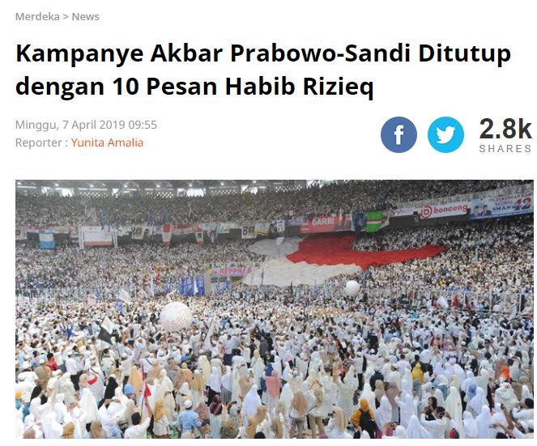
Figure 1: The Existence Of Religious Politics by The Candidate Prabowo-Sandi
Source : Merdeka.com, 7 April 2019
Furthermore, the candidate Number 1 is also engaged in populism based on an identity politics strategy. The populism of Candidate Number 1 is different from Paslon Number 2 because it is more of a backlash against political attacks based on a religious approach to Jokowi in particular. Selection of K.H. Ma'ruf Amin as Vice President is a political defense measure designed to prepare him for political attacks based on religious issues. It seems that presidential candidate Jokowi has learned from the defeat of DKI Jakarta Governor Ahok by Anies Baswedan, in which religious issues played an important role. The hope is to elevate K.H. Ma'ruf Amin as Vice President in order to be able to represent some Muslims, it is clear that Jokowi's presidential candidate is not anti-Islam and does not suffer from "Islamophobia", as supporters of Paslon Number 2 often say. related to discrediting in the context of "un-Islamic" in Paslon Number 1 in the end it did not become an issue of public trust or confidence (Ardipandanto, 2020).
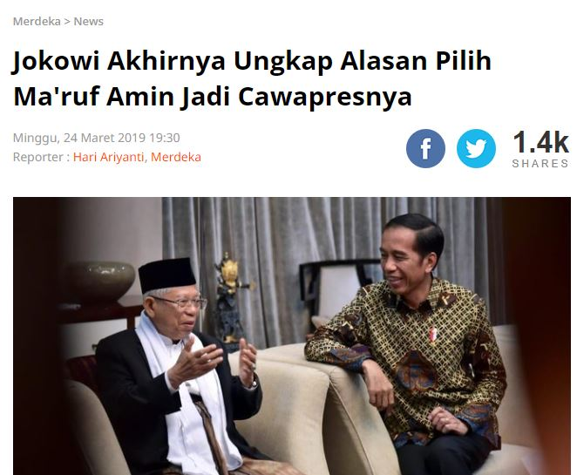
Picture 2 the existence of Religious Politics by the Candidate Jokowi-Amin
(source: merdeka.com, March 24, 2019)
Jokowi's election of Ma'ruf Amin as his cawapres finally received appreciation from the Banten students. In addition, Banten residents have also longed for a leader with a clerical background. When the cleric from Banten was sworn in as the number two candidate in the country, he was greeted enthusiastically by a large number of people. In the end, this has reflected that religious political discourse in the 2019 presidential election was very dominant, because it was used by the two pairs of candidates, namely Jokowi-Amin and Prabowo Sandi. In Indonesia, the history of religious politics has become a well-known phenomenon and fact. Long before Indonesia's independence in 1945, religious politics, especially political Islamization, had become commonplace in Indonesian society. The struggle for the 2019 presidential and vice presidential candidates is the impact of the use of religious symbols in the early stages of the 2019 presidential election.
At this point, Muslim identity becomes one of the determining factors for presidential and vice presidential candidates in the 2019 election. This identity arises not only because Indonesia is predominantly Muslim, but also because of the socio-political religious situation in Indonesia which has implications for the emergence and transmission of Muslim identity. Various events in the name of "religion" are proof that identity politics is and has become a factor in the Indonesian political system (Ronaldo & Darmaiza, 2021). A number of actions to Defend Islam ranging from Action to Defend Islam I (Action 1410), Action to Defend Islam II (Action 411), Action to Defend Islam III (Action 212 Volume 1), Action to Defend Islam IV (Action 212), Action to Defend Islam V (Action 212 Volume II) and Action to Defend Islam VI (Action 313) became a representation space for the strengthening of identity politics that carried religious symbols (Islam). These actions were suspected by Islamic groups and mass organizations ranging from the Islamic Defenders Front (FPI), the National Movement to Guard Fatwa (GNPF)-MUI and the Islamic Community Forum (FUI).
Public Participation in Religious Politics Discourse in the 2019 Presidential Election
Public participation is a metric to assess the quality of citizens in terms of their perspectives and responsibilities for the development and survival of democracy in a country. In addition, the purpose of public participation is to determine the nature and political orientation of the democratic system that underlies such participation (Djuwita, 2019). The implementation of the 2019 Presidential Election has visualized a number of interesting phenomena to explore and one of them includes matters relating to an increase in the level of public participation in the implementation of democratic parties in Indonesia.
When compared to the previous election, the 2019 presidential election has shown a higher voter participation and showed an improvement in public involvement in political contestation on a national scale. The following is the number of public participation in the 2019 presidential election as shown in the following image:
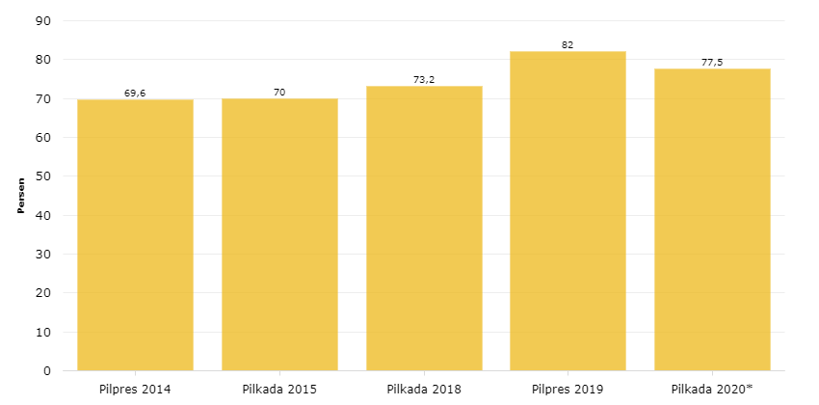
Picture 3 the amount of Public Participation in the 2019 Presidential Election
Source: (Katadata.co.id, 2020)
Public participation is a metric to assess the quality of citizens in terms of their perspectives and responsibilities for the development and survival of democracy in a country. In addition, the purpose of public participation is to determine the nature and political orientation of the democratic system that underlies such participation (Djuwita, 2019). The implementation of the 2019 Presidential Election has visualized a number of interesting phenomena to explore and one of them includes matters relating to an increase in the level of public participation in the implementation of democratic parties in Indonesia.
When compared to the previous election, the 2019 presidential election has shown a higher voter participation and showed an improvement in public involvement in political contestation on a national scale. The following is the number of public participation in the 2019 presidential election as shown in the following image:

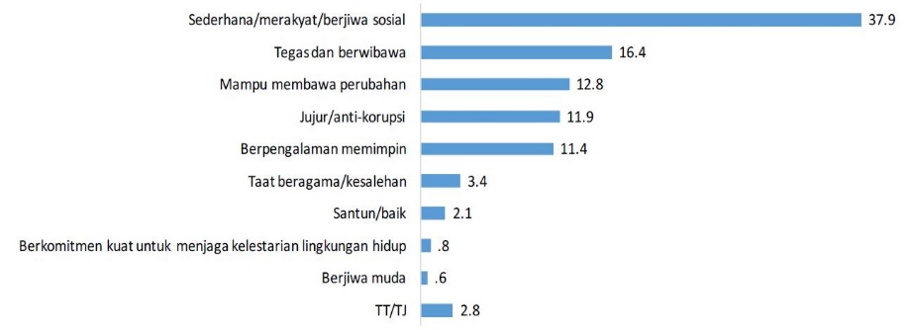
Picture 4 the Characters of the President Candidate considered by the Voters
(Source: Centre for Strategic and International Studies, 2019).
In Figure 4 above, it can be seen that the voting community in Indonesia has a number of considerations to give their voting rights to presidential candidates. These considerations are revealed from the results of a survey conducted by the Center for Strategic and International Studies (CSIS) for the period 15-22 March 2019, where simplicity is still the dominant dimension (37.9%), while religious factors only have a percentage (3 ,4%). Nevertheless, in the process it cannot be denied that at the momentum of the 2019 presidential election, it has become an arena for religious politics as a means of attracting voters. Both Jokowi and Prabowo are aware that highlighting the religious aspect with the right political strategy will increase their chances of winning the election. In essence, Jokowi-Amin won the 2019 presidential election because of the strong support from Nahdatul Ulama (NU) and nationalist groups so that they had a landslide victory in Central and East Java as well as other non-Muslim majority areas such as Bali, Papua, West Papua, North Sulawesi. , and NTT. Then, in areas based on strong Islam (puritanism) such as Aceh, West Sumatra, South Kalimantan, West Java, and Banten, Prabowo-Sandi also won a landslide victory. Thus, the 2019 presidential election shows that religious politics has contributed significantly to candidate wins and increased voter participation, so it is highly likely that this kind of religious-based identity sentiment will continue to be adopted in the future. This research is in line with Djuwita's research (2019) which confirms that community involvement or participation in the 2019 presidential election has reflected the public's desire to actively participate in determining the nation's leader candidates. In addition, public participation in the 2019 presidential election also depends on the interests of each individual, one of which is also influenced by the existence of religious political discourse.
CONCLUSION
This study concludes that religious political discourse is very dominant in the 2019 presidential election, because it is used by two pairs of candidates, namely Jokowi-Amin and Prabowo-Sandi in their religious narratives and symbols at the 2019 presidential election stage. Voter participation is 82.0% in the 2019 presidential election. This is in line with the results of the 2019 presidential election, both Jokowi-Ma'ruf and Prabowo-Sandi, which cannot be separated from the religious political discourse used, although this is not a single variable because the struggles and actions of political parties and their volunteers also contribute to attracting voters. Both Jokowi and Prabowo realize that highlighting the religious aspect with the right political strategy has increased their chances of winning the election, where public participation in the 2019 presidential election depends on individual interests, one of which is influenced by religious politics.
REFERENCES
Afriadi, A., Prisanto, G. F., Ernungtyas, N. F., Irwansyah, I., & Afriani, A. L. (2019). Komunikasi Politik “Rasa” Ala Jokowi Dalam Merespon Politik Sentimen. Wacana: Jurnal Ilmiah Ilmu Komunikasi, 18(2), 142–153. Https://Doi.Org/10.32509/Wacana.V18i2.928
Agam Primadi, D. E. & S. (2019). Peran Pemilih Pemula Dalam Pengawasan Pemilu Partisipatif. Journal Of Political Issues, 1(1), 63–73.
Alkawy, M. B. (2020). Legitimasi Legitimasi Majelis Ulama Indonesia (Mui) Dalam Kontestasi Islam Politik Mutakhir. Al Ma’arief : Jurnal Pendidikan Sosial Dan Budaya, 1(2), 102–117. Https://Doi.Org/10.35905/Almaarief.V1i2.1046
Amrullah Umar, S. K. (2019). Pengaruh Politik Identitas Pada Pemilihan Presiden 2019 (Survey Terhadap Civitas Akademika Universitas Muhammadiyah Maluku Utara). Kawasa, 19(2), 11–18.
Ardipandanto, A. (2020). Dampak Politik Identitas Pada Pilpres 2019: Perspektif Populisme. Jurnal Politica Dinamika Masalah Politik Dalam Negeri Dan Hubungan Internasional, 11(1), 43–63. Https://Doi.Org/10.22212/Jp.V11i1.1582
Ari Ganjar Herdiansyah, Yusa Djuyandi, W. S. S. (2019). Partisipasi Generasi Muda Dalam Membentuk Masyarakat Pemilih Yang Cerdas Dan Dewasa Berpolitik Di Kecamatan Jatinangor. Dharmakarya: Jurnal Aplikasi Ipteks Untuk Masyarakat, 7(4), 252–256.
Assiddiq, D. U., & Ambarwati, D. (2021). Strategi Komunikasi Politik Tim Kampanye Daerah Joko Widodo – K.H. Ma’ruf Amin Provinsi Jawa Timur Dalam Pemenangan Pilpres 2019. Jurnal Nomosleca, 7(2), 107–117. Https://Doi.Org/10.26905/Nomosleca.V7i2.5846
Baharuddin, M. (2019). Partisipasi Publik: Isu Agama Dan Politik Dalam Konteks Demokrasi Di Media Online. Majalah Ilhiam Semi Populer Komunikasi Massa, 15(2), 165–172.
Centre For Strategic And International Studies (Csis). (2019). Laporan Hasil Survei Nasional: Pertarungan Antara Elektabilitas Dan Mobiliasi Pemilih.
Djuwita, A. (2019). Fenomena Pendapat Masyarakat Seputar Pilpres 2019. In Komunikasi Politik Indonesia (Pp. 157–166). Buku Litera.
Elok Perwirawati, Prietsaweny Riris T Simamora, L. V. S. (2019). Pola Komunikasi Kelompok Agama Dalam Pencegahan Penyebaran Ujaran Kebencian Di Kecamatan Medan Polonia Pada Pemilihan Presiden Tahun 2019. Jurnal Darma Agung, 27(3), 1124–1134.
Farida, L., & Yoedtadi, M. G. (2020). Politik Identitas Dalam Pemilihan Presiden 2019 (Analisis Framing Pemberitaan Kampanye Pilpres 2019 Pada Medcom.Id). Koneksi, 3(2), 358. Https://Doi.Org/10.24912/Kn.V3i2.6395
Fata, M. K. (2019). Membaca Polarisasi Santri Dalam Kontestasi Pilpres 2019. Jurnal Dinamika Penelitian: Media Komunikasi Sosial Keagamaan, 18(November 2018), 325–344.
Faturahman, B. M. (2018). Aktualisasi Nilai Demokrasi Dalam Perekrutan Dan Penjaringan Perangkat Desa. Jurnal Sosial Politik, 4(1), 132. Https://Doi.Org/10.22219/Sospol.V4i1.5557
Firmansyah, M. F., & Kurniawan, A. (2021). Literature Study Of Political Communication Based On Politic Identity And Symbolic Interactionism: The Role Of Middle Class In Information Of Democratization. The Spirit Of Society Journal, 5(1), 55–73.
Hamdani, R. S. (2020). Proyek Lintas Batas Administrasi: Analisis Partisipasi Publik Dalam Proses Perencanaan Ibu Kota Negara Republik Indonesia. Journal Of Regional And Rural Development Planning, 4(1), 43–62. Https://Doi.Org/10.29244/Jp2wd.2020.4.1.43-62
Haris, A., & Dardum, A. (2021). Kiai Nu Dan Politik (Keterlibatan Kiai Nu Jember Dalam Kontestasi Pilpres 2019). Fenomena, 20(1), 91–114. Https://Doi.Org/10.35719/Fenomena.V20i1.51
Hasibuan, R. (2019). Partisipasi Publik Dalam Proses Kebijakan Di Masa Reformasi. Jurnal Trias Politika, 3(1), 10. Https://Doi.Org/10.33373/Jtp.V3i1.2407
Hermawan, I. (2019). Metodologi Penelitian Pendidikan Kuantitatif, Kualitatif Dan Mexod Method. Hidayatul Quran Kuningan.
Holilah, I. (2020). Agama, Komunikasi Politik Dan Elektabilitas [Uin Syarif Hidayatullah Jakarta]. Http://Repository.Uinjkt.Ac.Id/Dspace/Bitstream/123456789/54783/1/Ilah Holilah - Sps.Pdf
Huda, M., & Dayat, M. (2019). Perspektif Kiai Silo Di Kabupaten Pasuruan. Kabilah: Journal Of Social Community, 4(1), 48–56.
Katadata.Co.Id. (2020). Bagaimana Partisipasi Pemilih Pilpres & Pilkada Dalam Lima Tahun Terakhir? Databoks.Katadata.Co.Id. Https://Databoks.Katadata.Co.Id/Datapublish/2020/07/07/Bagaimana-Partisipasi-Pemilih-Pilpres-Pilkada-Dalam-Lima-Tahun-Terakhir
Mahyuddin, Emilia Mustary, N. (2019). The Power Of Emak-Emak: Perempuan Dalam Pusaran Kampanye Politik Pemilihan Presiden 2019. Al-Maiyyah: Media Transformasi Gender Dalam Paradigma Sosial Keagamaan, 12(2), 1–15.
Merdeka.Com. (2019a). Jokowi Akhirnya Ungkap Alasan Pilih Ma’ruf Amin Jadi Cawapresnya. Merdeka.Com. Https://Www.Merdeka.Com/Politik/Jokowi-Akhirnya-Ungkap-Alasan-Pilih-Maruf-Amin-Jadi-Cawapresnya.Html
Merdeka.Com. (2019b). Kampanye Akbar Prabowo-Sandi Ditutup Dengan 10 Pesan Habib Rizieq. Merdeka.Com. Https://Www.Merdeka.Com/Politik/Kampanye-Akbar-Prabowo-Sandi-Ditutup-Dengan-10-Pesan-Habib-Rizieq.Html
Mohajan, H. K. (2018). Qualitative Research Methodology In Social Sciences And Related Subjects. Utc Journal Of Economic Development, Environment And People, 7(1), 23–48. Https://Mpra.Ub.Uni-Muenchen.De/85654/1/Mpra_Paper_85654.Pdf
Mujab, S., & Irfansyah, A. (2020). Komunikasi Politik Identitas K.H. Ma’ruf Amin Sebagai Strategi Depolarisasi Agama Pada Kontestasi Demokrasi Pilpres 2019. Warta Iski, 3(01), 54–66. Https://Doi.Org/10.25008/Wartaiski.V3i01.46
Patrik Aspers, U. C. (2019). What Is Qualitative In Qualitative Research. Qualitative Sosiology, 42(2), 139–160. Https://Doi.Org/Https://Doi.Org/10.1007/S11133-019-9413-7
Putra, D. A., Yazwardi, Y., & Fikri, M. S. (2021). Pengaruh Penggunaan Facebook Terhadap Hasil Pemilihan Presiden 2019. Ampera: A Research Journal On Politics And Islamic Civilization, 2(1), 1–14. Https://Doi.Org/10.19109/Ampera.V2i1.7427
Rif’an, F. A. (2020). Politik Identitas Dan Perilaku Pemilih Pada Pilpres 2019 Di Kota Palembang Sumatera Selatan: Studi Kasus Di Tiga Kelurahan. Uin Walisongo Semarang.
Rijal, A. (2019). Politik Tuan Guru Versus Politik Media “ Pilpres 2019 Di Lombok “ Antara Dakwah. Tasamuh, 16(2), 21–44.
Ronaldo, R., & Darmaiza, D. (2021). Politisasi Agama Dan Politik Kebencian Pada Pemilu Presiden Indonesia 2019. Indonesian Journal Of Religion And Society, 3(1), 33–48. Https://Doi.Org/10.36256/Ijrs.V3i1.150
Rubaidi. (2021). Politik Identitas Islam Indonesia Kontemporer: Radikalisme Islam Versus Moderatisme Islam Dalam Politik Elektoral Pilpres 2019 (Contemporary Indonesian Islamic Identity Politics: Islamic Radicalism Versus Islamic Moderatism In The 2019 Presidential Electi. Potret Pemikiran, 25(2), 149–167. Http://Journal.Iain-Manado.Ac.Id/Index.Php/Pp/Article/View/1593
Ruhana, A. S. (2019). Democratizing Public Participation In Maintaining Religious Harmony. Jurnal Dialog, 42(2), 124–133. Https://Jurnaldialog.Kemenag.Go.Id/Index.Php/Dialog/Article/View/328
Sahari, A. F. P. A. (2021). Pendidikan Politik Dan Isu Agama Dalam Pilpres (Studi Pada Mahasiswa Iain Manado Dan Uin Makassar). Jurnal Potret Pemikiran, 25(1), 44–59.
Salim, D. P. (2019). Politik Dan Agama Dalam Pemilihan Presiden Serta Calon Legislatif 2019 Serentak Di Sumatera Barat. Prosiding The 2nd International Seminar On Contemporary Islamic Issues: Contemporary Issues On Religion And Multiculturalism, 1–12. Https://Books.Google.Co.Id/Books?Id=5d7ldwaaqbaj&Pg=Pa184&Dq=Kategori+Pendapatan+Menurut+Suparyanto&Hl=En&Sa=X&Ved=0ahukewjwko72pmdpahxlzcskhawmb-Mq6aeikdaa#V=Onepage&Q&F=False
Sandy Anugrah Tangkas, Indiana Ngenget, & Musthofa. (2021). Gerakan Politik Gnpf-Ulama Dalam Pemilihan Umum Presiden 2019. Jurnal Indonesia Sosial Sains, 2(1), 114–130. Https://Doi.Org/10.36418/Jiss.V2i1.113
Selian, D. L., & Melina, C. (2018). Kebebasan Berekspresi Di Era Demokrasi: Catatan Penegakan Hak Asasi Manusia. Lex Scientia Law Review, 2(2), 189–198. Https://Doi.Org/10.15294/Lesrev.V2i2.27589
Sihidi, I. T., Roziqin, A., & Suhermanto, D. F. (2020). Pertarungan Populisme Islam Dalam Pemilihan Presiden 2019. Jiip: Jurnal Ilmiah Ilmu Pemerintahan, 5(2), 174–189. Https://Doi.Org/10.14710/Jiip.V5i2.8516
Sonny. (2019). Peta Politik Identitas Di Indonesia : Sebagai Bakal Cawapres Bakal Capres Inkumben Joko Widodo Pada Pilpres 2019. Renaissance, 4(01), 443–455.
Yuniartin. (2019). Framing Agama Dalam Politik Praktis. Jurnal Studi Agama-Agama, 2(Nomor 1), 59–70.
Zainal, F., & Megasari, N. F. (2019). Mempolitisasi Ruang Virtual: Posisi Warga-Net Dalam Praktik Demokrasi Digital Di Indonesia. Jurnal Ilmiah Manajemen Publik Dan Kebijakan Sosial, 306(1), 306–326.

