The Title Should Be Simple, Concise and Informative in Sentence Case Format (Arial Narrow 14; contains capitalize each word and bold; 1 space)

First Author ¹, Second Author ², (11 pt)

¹Affiliation, Country

²Affiliation, Country

ARTICLE INFO |  | ABSTRACT
Keywords:  first keyword;  second keyword;  third keyword  (max. five keywords)  Corresponding Author:  Name, E-Mail    Copyright © 20XX Author(s). Published by ELTALL: English Language Teaching, Applied Linguistic and Literature. ELTALL is licensed under a CC BY-NC 4.0 |  | An abstract should accompany each manuscript. It should be entirely self-consistent (i.e., with no figure, table, equation, or reference citations), not exceeding 250 words, and written as a single paragraph. Abstract using English and Indonesian. We strongly encourage authors to use the following style of structure abstracts, but without headings: (1) Background: Place the questions addressed in a broad context and highlight the purpose of the study; (2) Methods: Describe the main methods or treatments briefly applied; (3) Results: Summarize the article’s main findings; and (4) Conclusion: Indicate the main conclusion or interpretations. (Arial Narrow 11; 1 space)

INTRODUCTION (Arial Narrow 12 and bold) and its contents (Arial Narrow 12; 1.15 space)
The main text format consists of a flat left-right column on A4 paper (quarto) with the page margin; left (3.3 cm), top (4 cm), right (3.3 cm), and bottom (3.4 cm). The manuscript is written in Microsoft Word, single space, Arial Narrow 12 pt., minimum of 15 pages, and a maximum of 30 pages.
The introduction should briefly place the study in a broad context and highlight why it is essential. It should define the purpose of the work and its significance. The current state of the research field should be reviewed carefully and key publications cited. Provide broad definitions and discussions of the topic and incorporate others’ views (literature review) into the discussion to support, refute, or demonstrate your position on the topic. Please highlight controversial and diverging hypotheses when necessary. Finally, we briefly mention the main aim of the work and highlight the principal conclusions.

METHODS (Arial Narrow 12 and bold) and its contents (Arial Narrow 12; 1.15 space)
It should be written in paragraphs. It also explains the research approach, kinds of research, data collection technique, and data analysis. They should reflect and describe the purpose of the study appropriately

FINDINGS AND DISCUSSION (Arial Narrow 12 and bold) and its contents (Arial Narrow 12; 1.15 space)
It refers to the total of outcomes, the result of data analysis. The results should be discussed for each. The findings can be presented in figures, tables, and others that make the reader understand easily. Tables and Figures are presented in the center, as shown in Table 1 and Figure 1.

Table 1. Number of Students at X University
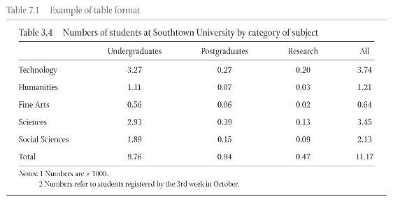
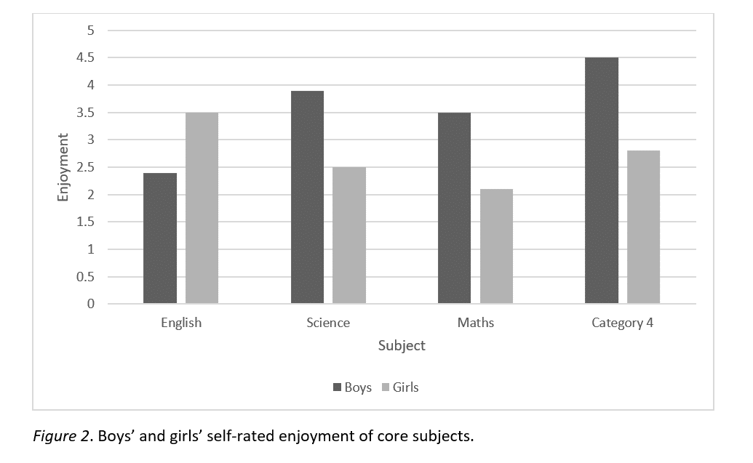
Figure 1. Boy’s and girl’s self-rated enjoyment of core subjects
The discussion interprets and describes the significance of the findings regarding the already known research problem being investigated. It also explains any new understanding or insights emerging from the theories and/or the other research. It should also provide a concise and precise description of the experimental results, their interpretation, and the experimental conclusions are drawn. Future research directions may also be highlighted.

CONCLUSION (Arial Narrow 12 and bold) and its contents (Arial Narrow 12; 1.15 space)
Section title should be “Conclusion,” not “Conclusions.” Provide conclusion (s) related to the upcoming idea(s) coming from the result(s) of the current research.
REFERENCES (Arial Narrow 12 and bold) and reading sources (Arial Narrow 12; 1.15 space)
References should be cited both in the text and in the references list. They should conform to the APA of 6th Edition style. It should be listed in alphabetical order. Please ensure that all information in the manuscript taken from another source is substantiated with an in-text reference citation. References consist of the citations in the publication text with a minimum of 10 references. References must be up to date. A minimum of 80% of sources published 10 years recently is required for each submission.
Please note that your references must follow the APA of 6th Edition style. The editor will return the submission for correction if the writer does not read format references correctly. Author (s) may employ Zotero, Mendeley, Endnote, etc., as the Reference Management.

Brown, H. D. (2002). English language teaching in the postmethod era: Toward better diagnosis, Treatment, and Assessment. In J. C. Richard & W. A. Renanyda: Methodology in language teaching. New York: Cambridge.
Casey, M., & Stephens, M. (2014). The transparent library. Retrieved from http://tametheweb.com/wpcontent/uploads/2014/03/TheTransparentLibrary2.pdf
Cheung, J. M. Y., Bartlett, D. J., Armour, C. L., Laba, T. L., & Saini, B. (2018). To drug or not to drug: A qualitative study of patients’ decision-making processes for managing insomnia. Behavioral Sleep Medicine, 16(1), 1-26. doi:10.1080/15402002.2016.1163702
Kyratsis, A. (2014). Talk and interaction among children and the co-construction of peer groups and peer culture. Annual Review of Anthropology, 33(4), 231-247.
Richards, J. C. & Rodgers, T. S. (2011). Approaches and methods in language teaching. Cambridge: Cambridge University Press.

