INSECTA Vol. XX No. XX, 2020, pp. XX - XX

Available online at
INSECTA
Integrative Science Education and Teaching Activity Journal
Journal homepage : https://jurnal.iainponorogo.ac.id/index.php/insecta

Article

Development of Sigil-Based Additives and Addictive Substances Teaching Chart for Junior High School Students: Alternative Learning Resources During a Pandemic
Nor Imamah^{1*}, Laily Yunita Susanti²

¹Institut Agama Islam Negeri (IAIN) Jember, Jember Indonesia
² Institut Agama Islam Negeri (IAIN) Jember, Jember Indonesia

*Corresponding Address: susantilaily89@gmail.com

Article Info |  | ABSTRACT
Article history:  Received: Month XX, 20XX  Accepted: Month XX, 20XX  Published: Month XX, 20XX  (Times New Roman 9) |  | Research and development of sigil-based teaching materials based on facts in the field, namely students rarely read textbooks in print because of the lack of attractive appearance. When in the classroom students tend not to pay attention because the learning used by teachers is often conventional and rarely uses the media. Teaching materials are needed by students in learning activities that can be used anytime and anywhere so that learning activities can be efficient. The purpose of the study was to describe the validation results and the students' response to sigil-based teaching materials for junior high school. This type of research is R&D (Research and development) research and development. The development model in the study used a model developed by Thiagarajan 4-D. Validation results then products in the field test to find out the student's response. The results of the assessment of material experts 98.75%, media experts 91.42% and user experts 92.30%, all three have a high percentage so that the digital teaching materials developed have "very valid" criteria. Small-scale trial results percentage result is 78.4% so that includes the criteria "interesting". The large-scale trial resulted in a percentage of 83.33% so that it included "very interesting" criteria.
Keywords:
Teaching materials
Sigil
Additive
Additive substance
Efficient
© 2020 Tadris Ilmu Pengetahuan Alam Department, IAIN Ponorogo, Indonesia.
INTRODUCTION
Advances in the development of technology, information and communication are growing very rapidly, thus human activities are getting easier (Suyono & Nurohman. S., 2014). This can be felt, especially in the field of education. Things that support education are very important to be implemented and implemented (Nopriadi, et al., 2015). The need for technology assistance in the field of education to be utilized and help teachers in delivering materials.
Students are the center of technological civilization so the use of technology, information and communication is very important. Technology was used as an educational base in the era of industrial revolution 4.0. The main need of students in the era of revolution 4.0 is to use technology-based learning, information and communication which is next to face society 5.0.
The development of technology, information and communication has developed rapidly in various circles of the general public. With the development of technology, information and communication of human activities is getting easier. Things that support education are very important to apply and implement. The need for technology in education to take advantage of technology in education so that it makes it easier for teachers to apply it as a tool for delivering material to students. Educators (teachers), students (students), and the curriculum are the three main components that interact with each other in learning technology.
Based on this, developing science and technology can be utilized in learning, especially in the learning process on science materials. New breakthroughs are needed as an effort to keep up with advances in technology and science for teachers. Natural Sciences (SCIENCE) is an integrated learning taught in junior high school. Science learning is a learning that includes three materials, namely biological materials, chemical materials and physical materials. IPA discusses the phenomena of natural knowledge that are visible or not visible ( Wonoraharjo Surjani., 2011).
Science learning of chemicals in junior high school, especially additives and addictive substances (Kemendikbud, 2017), the characteristics of additives and addictive substances are emphasized on factual and conceptual materials that are directly related in daily life (Darma. S & Iswendi, 2018). So there needs to be media that contain images and videos in order to help teachers bring the outside world into the classroom. So that the factual and conceptual material thus becomes contextual. Additive and addictive material is only taught through theory and memorization in the classroom so that in its implementation must be assisted with teaching materials that support so that learners can understand the material. With this material will also add information to students against the dangers of additives and addictive substances. So that students can be aware and vigilant so as not to get caught up to be affected and follow abuse such as drugs, drinking, and other additives.
One of the efforts to succeed in learning for students is the availability of teaching materials that are easy to understand. Thus, a teacher is required to be creative, innovative, and able to make communicative teaching materials. Teaching materials are essential learning resources that are important in learning to support teacher performance and encourage teacher efficiency. Teaching materials must adapt to the rapid development of knowledge and technology in the community. Teaching materials that are maintained too long will become obsolete such as printed teaching materials. Teaching materials can be used as learning supplement books, namely supplementary books or complementary to the content of certain materials so that students understand more about the material being taught at school.
The development of learning facilities based on digital development has not been fully utilized in the world of education. Teachers or schools still use printed and simple audio-visual teaching materials. Digital can be used as a special learning media for students. The development of digital teaching materials is an opportunity for the world of education to increase learning activities that provide learning material resources that can be accessed anytime and anywhere.
Based on the facts in the field, students are bored in learning activities in the classroom because teachers often use conventional learning, students are lazy to read books because they look less attractive, and when in the classroom students want to see videos related to learning materials. One of the successful efforts in learning for students is the availability of teaching materials that are easy to understand. Thus, a teacher is required to be creative, innovative, and able to make communicative teaching materials. Teaching materials are an important essential learning resource needed in learning to support teacher performance and encourage teacher efficiency. Teaching materials must adjust to the rapid development of knowledge and technology among the community (Nasution, 2010). Teaching materials that are too long maintained will become obsolete like printed teaching materials. Teaching materials can be used as supplementary books that are additional books or complements the content of certain materials so that students understand more about the materials taught in school.
The development of learning facilities based on digital development has not been utilized to the maximum in the world of education. Teachers or schools still use printed teaching materials as well as simple audio-visual teaching materials. Digital can be used as a special learning media for students (Abidin & Rohati, 2014). The development of teaching materials based on sigil is an opportunity for the world of education to improve learning activities that provide resources that can be accessed anytime and anywhere. During the Covid-19 pandemic, students are encouraged to study at home.
After the Covid-19 pandemic the government issued a policy for students to study at home and replaced with online learning. Many schools were closed to avoid face-to-face with the crowds. The negative impact of many complaints from parents about internet packages. Thus, alternatives are needed to keep students learning at home without using internet access. The first case of Covid-19 in Wuhan, then an increase in China every day peaked in late January to early February 2020. The first report of Covid-19 in Indonesia on March 2, 2020 consisted of 2 cases ( Adityo Susilo, et. Al., 2020).
One of the media that can support learning is sigil software. Sigil software has economic value that can help students to study at home without using internet packages and more flexible because it is efficient so that it can be used as a learning medium anytime and anywhere. Some conveniences in terms of features and friendly output produced by software sigil (Wirasasmita, R. H., & Uska. M. Z., 2017). With this sigil software can make its own digital-based teaching materials and can be shared for free. Digital-based teaching materials can be accessed on many electronic components both in PCs, Laptops, even in mobile phones.
Based on the above problems by considering alternative solutions, it is necessary to develop digital-based teaching materials. Digital-based teaching materials using sigil is expected to help students read materials more often wherever and whenever so as to add information, can be active in the learning process and can be a source of independent learning that students can bring so as to make time in the learnSing process.

METHOD
This research was conducted using the research and development method of R&D (Research and development). Development research is research that aims to produce new products or improve existing products (Sugiono., 2015). The products developed in this study are digital-based teaching materials using sigil in additives and addictive substances for junior high school students.
The development model in this study uses a model developed by Thiagarajan 4-D Define (definition stage), Design (design stage), Develop (development stage), and Disseminate (deployment stage), only up to the development stage because it is only to determine the feasibility and student responses to digital teaching materials, insufficient funds and limited time (Sutarti, T., & Irawan, E., 2017).
The development procedure is the steps that researchers will take in developing a product. The procedure for developing digital-based teaching materials for additives and addictive substances for Junior High School Students uses a model developed by Thiagarajan 4D-model. The development steps that will be carried out are as follows hap:
At the devinition stage, it aims to determine and define the conditions of learning. This stage is carried out by analyzing the objectives within the boundaries of the subject matter to be developed in the learning media. Do some analysis viz : 1) Preliminary analysis aims to determine the basic problems faced in learning chemistry at Junior High School Students. In this case, what needs to be studied is the curriculum and problems in the field so that solutions are needed in accordance with the problems at hand. Curriculum analysis is to analyze the core competition and basic competencies first. Core competition and basic competencies can be seen in table 3.1. 2) Student analysis aims to analyze student characteristics. So it is necessary to know the deficiencies experienced by students when learning in class. 3) Concept analysis is carried out by identifying the main concepts being taught, collecting data and detailing relevant concepts to the predetermined basic competencies, and systematically rearranging them. Indicators can be seen in table 3.2. 4) Task analysis aims to identify the main skills that will be assessed by the researcher and analyze them into additional skill sets that may be needed. This analysis ensures a thorough review of the assignments in the learning material. In addition, task analysis can also make it easier for teachers to formulate specific goals to be achieved. 5) Formulate learning objectives the researcher converts the results of task analysis and concept analysis into specific learning objectives. The formulation of learning objectives is adjusted to the indicators that have been made based on the analysis of Core Competencies and Basic Competencies in the 2013 curriculum on additives and addictive substances.
At this stage develop, the format of the digital-based teaching materials is developed. In addition, designing digital-based teaching material content includes activities on each additive and addictive sub-material. At this stage the design is focused on the initial design of the product in the form of digital-based teaching materials with predetermined material. The initial design of teaching materials is attractive, the content of the material is easy to understand so that students are interested in reading and using it in learning activities. The initial product of digital-based teaching materials was adjusted to the advice and input of the supervisor. After the product is complete, then make an instrument design, including a validation instrument and a student response questionnaire.
At this stage develop the researchers developed digital-based teaching materials using sigil. First, the researcher designs the section that corresponds to each part of the teaching material which consists of the initial cover, the content / material, and the final part. The second stage, the researcher wrote the contents of the additive and addictive material in microsof word and then imported it into HTML. The third stage, importing into the sigil by providing additional covers, images, and videos. Teaching materials can be opened using the readium application if using a laptop, lithium and a reader if using a cellphone.
After the product is made, the next step is validated by several experts. Validation is carried out by material experts, media experts and user experts to determine product feasibility. Researchers provide validation questionnaires to all experts to determine product deficiencies. The responses and suggestions given by several experts are used to improve the products being developed. The material expert validation was carried out by Dr. A. Suhardi, S.T., M. Pd and media validation by Rafiatul Hasanah, S. Pd., M. Pd and a science teacher namely Edy Susanto, S.Pd as user experts. After that, the small group test was carried out by 6 students representing 2 students of class VIII B, VIII C, and VIII D consisting of medium and high learning achievement respectively. Furthermore, the large group trial using class VIII A Junior High School Students Plus Darus Sholah involved 31 excellent students.
The technique used to collect data is quantitative data and qualitative data obtained from expert validation sheets in the form of questionnaires. Quantitative data in the form of validity test results of experts and teachers as well as the results of student response questionnaires. The results of quantitative data analysis are used to determine product feasibility. Qualitative data in the form of description of criticism, suggestions and inputs in the form of comments from experts and the use of instruments as product improvements.
After at this stage, product revisions are carried out after validation by material experts, media experts, and user experts. The results of the validation are an assessment score, validator comments and suggestions to improve the weaknesses and deficiencies of the product. The learning product is improved so that it becomes a product that is feasible to be tested on a limited basis.
Small group trials were carried out to determine the legibility of the digital-based teaching materials being developed. This stage is carried out by providing digital-based teaching materials using sigil on the condition that students first download a reader or lithium on their cellphone. Student suggestions and comments are used for the second revision stage of teaching materials, after which small group trials are carried out.
After the product was revised, a large group trial was conducted. This stage is carried out to determine the attractiveness and suitability of content to the digital teaching materials being developed. This stage is carried out by providing digital-based teaching materials using sigil on the condition that students first download a reader or lithium on their cellphone. Student suggestions and comments are used for the third revision stage of teaching materials, after which the teaching materials can be used in the learning process.
Data analysis used is a descriptive statistical analysis. The analysis can describe or describe objects studied through sample or population data, not intending to draw conclusions in general (Mundir, 2013). Descriptive analysis techniques are used to describe the product development of teaching materials and manage data in the form of comments and suggestions obtained from questionnaires. The results of the description were used by researchers to revise the products developed in the form of teaching materials.
The assessment instruments used in data collection in this study used validation questionnaires and response questionnaires. The questionnaire used in this study is in the form of a checklist with a score assessment on each aspect using a likert scale of 1-5 (Sahlan., 2015). The criteria of each assessment scale are used as follows:

Table 1. Criteria of Each Assessment Scale
No. | Criteria | Shoes
1 | Verry Good or Vety Agree | 5
2 | Either or Agree | 4
3 | Simply or Less Agree | 3
4 | Less or Disagree | 2
5 | Very Lack or Very Disagree | 1
Source: Sahlan, 2015

The percentage of student responses and validations that respond according to certain criteria, namely with the following formula:

V-ah= x 100 %

There are criteria for the feasibility test of teaching materials presented in the table below:
Table 2. Teaching Materials Feasibility Test Criteria
No. | Validity Criteria | Validity Level
1 | 85,1%-100,00% | Very valid or usable without revision
2 | 70,01%-85,00% | Fairly valid or usable but needs a small revision
3 | 50,01%-70,00% | Less valid, recommended not used because it needs major revisions
4 | 01,00%-50,00% | Invalid or may not be used
Source: Sa’dun Akbar, 2016

Criteria for the availability of digital-based teaching materials products by the audience (students) descriptively include:

Table 3. Criteria of Illumination
No. | Assessment | Criteria
1 | 81%-100% | Very Interesting
2 | 61%-80% | Interesting
3 | 41%-60% | Quite Interesting
4 | 21%-40% | Not Interesting
5 | 0%-20% | Very Un interesting
Source: Sa’dun Akbar, 2016

RESULTS AND DISCUSSION
Based on student analysis, task analysis, concept analysis, and analysis of learning objectives. This is done to obtain information before making digital-based teaching materials. The materials used in making teaching materials are additives and addictive substances. Furthermore, conducting curriculum analysis which then formulates core competition and basic competencies to formulate indicators of achievement and learning objectives so that students can understand the material according to the 2013 curriculum used by the school.
The teaching materials developed are adapted to the characteristics of students by making observations so that they can find and identify the problem. Students often feel bored when learning activities take place because learning activities are often conventional. Students tend to want to see videos related to the material so that the learning atmosphere is more interesting. Students rarely read books because the appearance of the books is colorless and less attractive so that students' knowledge is still lacking. This can be proven when the teacher asks questions about student material tends to be passive.
So it is necessary to develop teaching materials that are in accordance with the characteristics of students and can be used anytime and anywhere. So that researchers develop digital-based teaching materials using sigil so that students can learn to use laptops in class and can also learn to use cellphones outside of class.
Based on curriculum analysis and student analysis, the material used by researchers in making teaching materials is additive and addictive. Furthermore, the researchers conducted curriculum analysis which then formulated core competition and basic competencies to formulate indicators of achievement and learning objectives so that students could understand the material in accordance with the 2013 curriculum used by the school. Additive and addictive material is factual and conceptual so it is necessary media that can help students to lead in contextual learning.
The media developed is digital-based teaching materials using sigil in additive and addictive materials for junior high school. The product being developed is non-print (electronic) using the ebup format. Digital-based teaching materials can be used using laptops and cellphones so that they can be used anytime and anywhere. In accordance with the current development where many students have used digital tools in everyday life to make learning easier. So that researchers use the sigil application to make digital-based teaching materials.
The teaching materials developed are adapted to the characteristics of the students by conducting observations during the internship. Researchers found and authenticated the problem that students often feel bored during learning activities because learning activities are often conventional. Students tend to want to see videos related to the material to make the learning atmosphere more interesting. Students rarely read books because the appearance of the book is colorless and less interesting so the student's knowledge is still lacking. This can be proven when the teacher gives questions about the material students tend to be passive. So there needs to be a media that can attract students learning anywhere and anytime by utilizing technology (Wirasasmita, R. H., & Uska. M. Z., 2017).
After making the design make a format of teaching materials. Then the researchers chose the sigil application to develop teaching materials. Researchers choose sigil application because it can be advantages, namely: (a) easy to carry because it is soft copy used by readers; (b) not heavy, digital books are simply incorporated into portable electronics, so that is carried only portable devices; (c) easily duplicated, digital books are easy to copy for free so will save costs and will support learning needs; (d) paper saving, in the era of global warming means we have supported the go green carried today (Yusnimar, 2014).
There are 3 (three) aspects of digital-based teaching materials, namely the introduction, learning/material, and closing. In the introduction, there is information related to the material to be studied, namely user manuals, core competition and basic competencies, indicators, and concept maps. In the content section, there are additive and addictive substances and there are several questions. In the closing section, there is a summary, glossary, brain teaser, keywords and a list of the author's details.
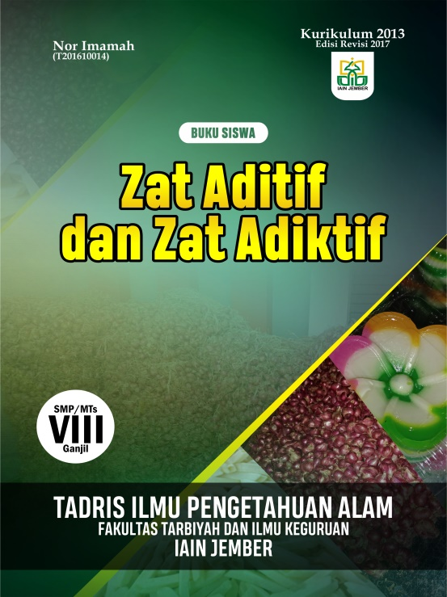
Picture 1. Teaching Material Cover Display

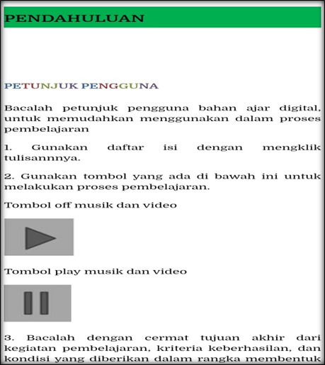
Picture 2. Display Teaching Material User Guide

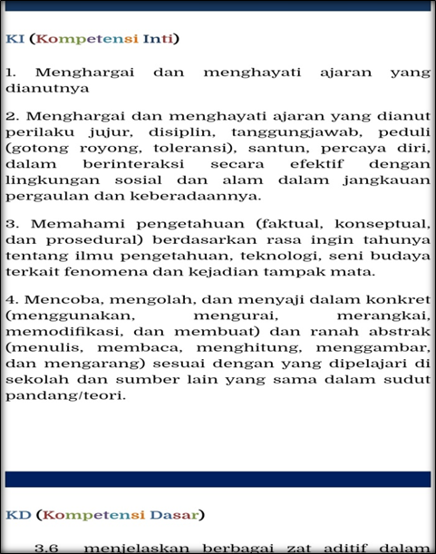
Picture 3. Display of the Core Competencies of Teaching Materia
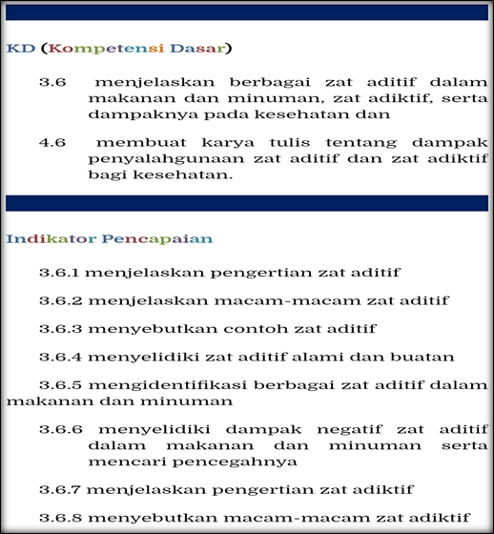
Picture 4. Display of Basic Competencies and Indicators of Teaching Materials

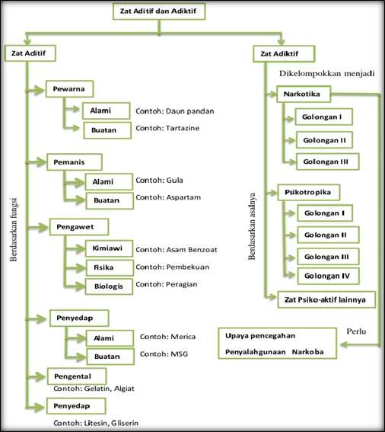
Picture 5. Teaching Material Concept Map Display

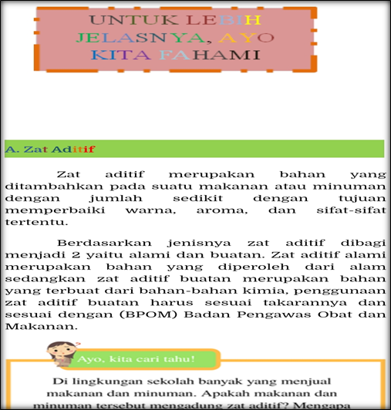
Picture 6. Display of Teaching Materials
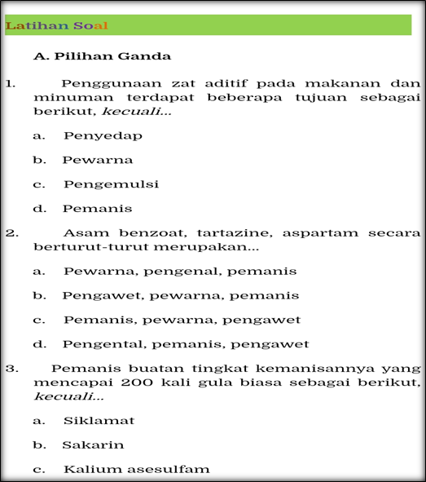
Picture 7. Display of Practice Problem Teaching Materials

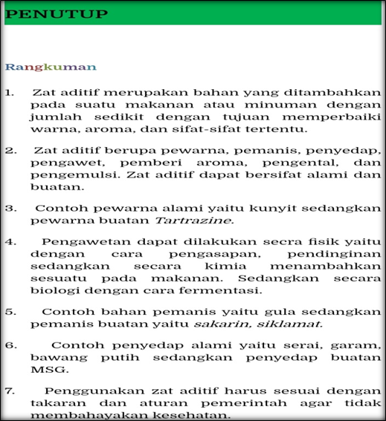
Picture 8. The Summary of Teaching Materials

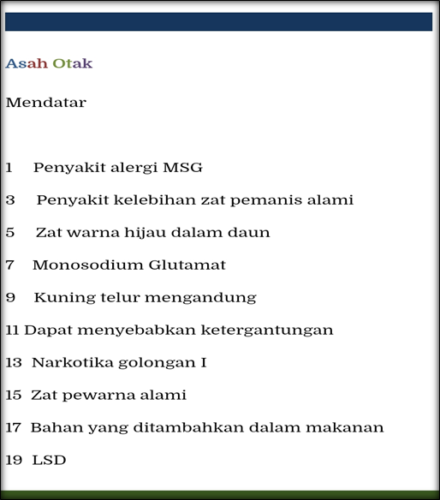
Picture 9. Display of Brain Teasers Teaching Materials
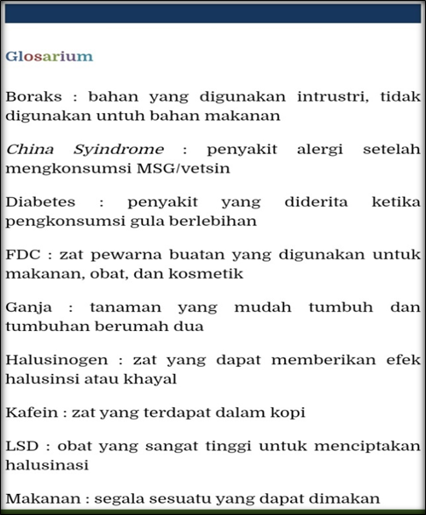
Picture 10. Teaching Materials Glossary Display

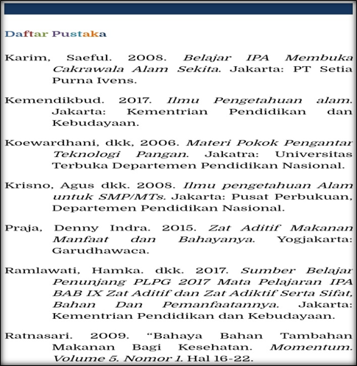
Picture 11. Bibliography Display of Teaching Materials

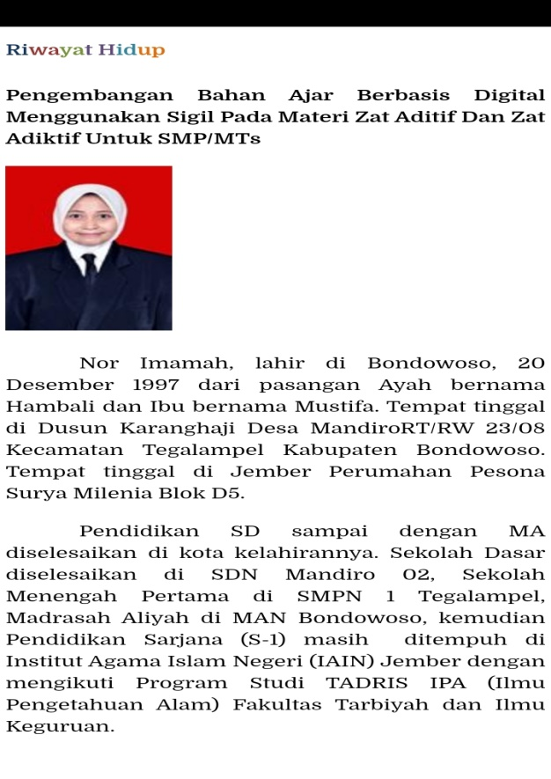
Picture 12. Curiculum vitae view

Digital-based teaching materials can increase students' interest in utilizing laptops and mobile phones. Digital-based teaching materials using sigil can be used for free and can be used for everyone. Sigil provides convenience in learning so that it is one of the problem solving in the world of education, especially in the form of teaching materials based on digital. The use of sigil software can be used as a learning media maker software that provides material resources and has economic value among students.
Digital-based teaching materials use EBUB extensions, because EBUB extensions support text display adjustments that match the display screen to be used so that digital teaching materials can be used using laptops, mobile phones, tablets, and mobile phones that can support EBUP-filled files. Devices used to open EBUP files if using a student's laptop are recommended to install readium excretion while if using a student's mobile phone it is recommended to install IReader, ebubreader, lithium and other excretions.
The display of materials in sigil-based teaching materials is equipped with neatly arranged sub-materials such as table of contents so that students in using teaching materials are very easy to open the page that you want to read, by pressing the links that are already available in the table of contents (Sofyan. G.A., & Listiawan. T., 2019).

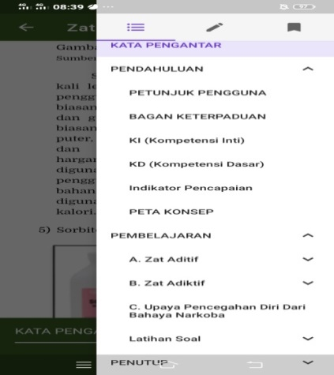
Picture 13. Table of Contents View of Teaching Materials

Sigil-based teaching materials are different from printed books because they can contain audio and video in the book (Jannah. N. et al., 2017). Videos contained in sigil-based teaching materials can be learned by students anytime and anywhere without having to access using the internet. With the video contained in the teaching material makes it easier for students to better understand the material and to reflect students so as not to get bored in using teaching materials sigil.

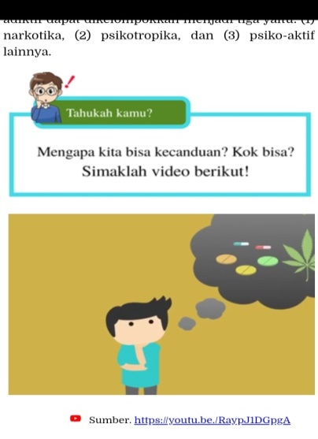
Picture 14. Teaching Materials Video Display

Textbook criteria that are eligible for use according to the education unit must meet the following elements (Kemendikbud., 2016):
- Leather books consist of the front skin of the book, the back skin of the book, and the back of the book.
- The initial section consists of title pages, publishing pages, preface pages, table of contents pages, table pages, and page numbering.
- The content section consists of material aspects, aspects of language, aspects of presentation of materials, and aspects of kegrafikan.
- The final section consists of bookkeeper, glossary, bibliography, index, and attachment.

As for a good teaching book and worth using, namely: 1) Accurate, to get a good book that requires accuracy. Accuracy can be seen from the aspects: the accuracy of presentation, properly exposing the results of research and not misquoting experts; 2) Using the correct language rules; 3) The book learns its readability according to the reader's understanding; 4) Complete and systematic, there are competencies, table of contents, and presentation of library lists; 5) Communicative, the content of teaching materials can be digested by the reader, clearly, does not contain language validity, and systematic; 6) Relevant, teaching materials in accordance with the competence that must be mastered with the scope of the depth of discussion, content, and competence of the reader; 7) Student centered oriented, where students can interact with teaching materials, stimulate their own knowledge, and encourage students to learn; 8) Side to the ideology of the nation and state (Akbar. S., 2013).
One of the main criteria for determining whether a product is worth using or not is the result of expert validation. The assessment of experts can be obtained from expert validation instruments. Based on the assessment of material experts in the form of quantitative and qualitative data, kualitaif data in the form of comments and suggestions that is cover on teaching materials are made more interesting to so that it is necessary to make revisions and kuantitafif data based on the calculation results using a percentage formula obtained by 98.75%. Once viewed with the product feasibility table, it is on a very valid criteria. . Assessment validation media experts there are 3 (three) aspects of assessment include, aspects of completeness of teaching materials, material aspects, and aspects of learning. The data of material expert validation results are presented in the table below:

Table 4. The Results of the Material Expert Validation of Each Aspect
No. | Indicator | Percentage %
1 | Completeness of the Teaching Charrt | 96%
2 | Material Aspects | 100%
3 | Aspects of learning | 100%
Source: Research Data, 2020

Based on media experts comments and suggestions as a whole are: (1) The use of images in the cover using its own documentation; (2) Inconsistent letter writing; (3) The images in the IPA information are less colorful. Kuantitatif data based on the calculation results using the percentage formula obtained by 91.42%. Once viewed with the product feasibility table, it is on a very valid criteria. Media expert validation assessment there are 5 (five) aspects of assessment including the effectiveness of screen design, ease of program optimization, consistency, format, and animation. Media expert validation data is presented in the table below:

Table 5. The Results of the Media Expert Validation of Each Aspect
No. | Indicator | Percentage %
1 | Aspects of Screen Design Effectiveness | 90%
2 | Aspects of the Ease of Operation of the Program | 95%
3 | Consisstency Aspect | 80%
4 | Format Aspect | 100%
5 | Animation Aspect | 93%
Source: Research Data, 2020

Based on expert user comments and advice as a whole that is Exercise questions need to be added and given essays. Antitafif data based on calculation results using a percentage formula obtained by 92.30 %. After looking at the product feasibility table, it is on the criteria of very valid user expert validation assessment there are 3 (three) aspects of assessment covering material aspects, presentation aspects, and language aspects. The data of user expert validation results are presented in the table below.

Table 6. The Results of Validation Expert users of Each Aspect
No. | Indicator | Percentage %
1 | Material Aspects | 93%
2 | Presentation Aspect | 94%
3 | Aspects of language | 93%
Source: Research Data, 2020

The results of the assessment of material experts, media experts and user experts all three have a high percentage so that in accordance with the book Sa'dun Akbar digital teaching materials developed has a criteria "very valid" so that it can be concluded that digital teaching materials are very feasible to use.

Table 7. Recapitulation of the Validation of Three Experts
No. | Validation | Percentage | Kriteria
1 | Material Validation | 98,75% | Very Valid
2 | Media Validation | 91,42% | Very Valid
3 | User Validation | 92,30 % | Very Valid
Source: Research Data, 2020

To find out the elixness of teaching materials can be done by disseminating student response questionnaires. In the questionnaire, students saw the lightness of teaching materials on the display of covers, images, videos, sentences and language that are not confusing and easy for students to understand. Teaching materials can be used in learning in terms of materials, examples of questions and videos that are already in the book so that students do not get bored in using the teaching materials. Comments from students are mostly interesting teaching materials because there are videos and teaching materials based on sigil can be used in this era where students have used a lot of mobile phones and laptops (Nafi’ah. U & Utami. I. W. P., 2017).
Sigil-based teaching materials are publications of digital text, images and videos that can be produced, published, and used through computers or other digital tools. The results of the test of learning materials based on sigil can be seen from the student response questionnaire that has been shared. The percentage of small-scale trial results in 6 students resulted in a percentage of 78.4% according to Sa'dun Akbar's book including "interesting" criteria in small-scale trials, to find out the readability of teaching materials. Furthermore, the analysis of large-scale trials in grade VIII A of 31 students resulted in a percentage of 83.33% according to Sa'dun Akbar's book including "very interesting" criteria in large-scale trials, to find out the usefulness and appropriateness of content with students' cognitive towards teaching materials.
Table 8. Recapitulation of Trials
Testing | Percentage | Criteria
Small Scale Trial | 78,4% | Interisting
Large Scale Trials | 83,33% | Very Interisting
Source: Research Data, 2020

Therefore, the data can be concluded that sigil-based teaching materials are feasible and interesting to use, both for teachers and for students. For teachers can be used in the classroom during the learning process while for students can be diguakan anytime and anywhere.
Before the teaching materials are used by students, the teaching materials must first consult the material according to the students' needs. After consulting revised teaching materials. Revisions were made to improve the product.

Table 9. Material expert product revision
Testing | Parts that need revision | The revised section
Material expert | Cover is made more attractive like a book  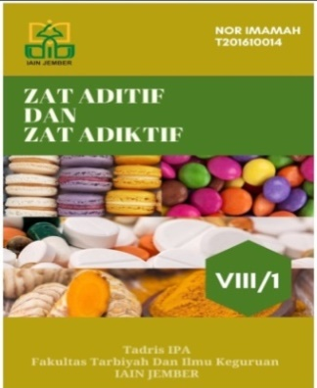 | Cover has been revised  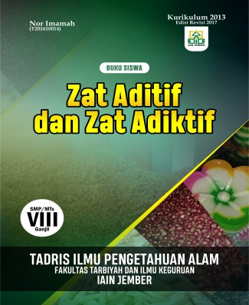

Based on the results of product analysis by media experts, revisions need to be made to improve the product. Revisions were made based on data obtained from media experts.
Table 10. Media expert product revision
Testing | Parts that need revision | The revised section
Media expert | - The picture in natural sciences informasion must be more colorful  - The writing of letters is less consistent  - The image on the cover must use the photo itself, not from google | - The natural sciences information image is more colorful  - Writing of letters is consistent  - The pictures on the cover are not taken on google

Based on the results of product analysis by expert users, revisions need to be made to improve the product. Revisions were made based on data obtained from media experts.
Tabel 11. User expert product revision
Testing | Parts that need revision | The revised section
Expert user | Practice questions need to be added and an essay is given | The practice quwstions have been added and an essay has been given

Digital-based teaching materials development results have the following advantages and disadvantages:
- Product advantages
- Digital-based teaching materials that are used are easy to apply because they can be opened on mobile phones and laptops.
- In use is not confusing and easy.
- Accessed offline so that it does not become an obstacle when the use runs out of data packages but wants to use digital teaching materials.

- Product deficiencies
- Materials in digital teaching materials developed only to the extent of additives and addictive substances.
- Requires ebup reader to open it.

CONCLUSION
This research is a type of research and development R & D (Research and development) with a model developed by Thiagarajan 4-D Define (definition stage), Design (design stage), Develop (development stage), and Disseminate (deployment stage), only up to the stage. development because only to find out the feasibility and response of students to digital teaching materials, insufficient funds and limited time.
The results of the validation questionnaire regarding the appropriateness of the results of the evaluation of material experts are 98.75%, media experts 91.42% and user experts 92.30%, all of which have a high percentage so that the digital teaching materials developed have criteria of "very valid" so it can be concluded that the teaching materials digital is very feasible to use. Digital-based teaching materials are in accordance with the 2013 core competition and basic competencies curriculum and student characteristics where the teaching materials already contain audio and video that can reflect students to learn to use digital-based teaching materials.
The results of the student response questionnaire regarding the attractiveness of the small-scale trial results on 6 (six) students the percentage result was 78.4% so that it was included in the “interesting” criteria in small-scale trials. Furthermore, the analysis of large-scale trials in class VIII A, which contained 31 students, had a percentage of 83.33%, so it was included in the criteria of "very interesting" in large-scale trials.

SUGGESTION
The results of existing research can be given the following suggestions:
- Digital-based teaching materials need to be maximized in order to hold up to effectiveness.
- It is hoped that digital teaching-based materials using sigil in materials for additives and addictive substances developed can be used in other schools.
- Research on sigil-assisted digital-based teaching materials can be carried out by interested readers in addition to additive and addictive substances.

REFERENCE
Abidin., & Rohati. (2014). Development of Interactive Mathematics Learning Media Based on Android to Foster Learning Motivation for Dyslexic Children on Exponential Materials in Jambi City. Edumatica 4( 2), ISSN 2088-2157, 68.
Adityo susilo, et. Al. (Maret 2020). Coronavirus Disease 2019: Recent Literature Review. Indonesia Journal of internal Medicine, 7(1), 45.
Akbar, S. (2013). Instrument Learning Device: PT. Remaja Rosdakarya, 34.
Darma., S., & Iswendi. (2018). Development of the Ludo Word Game (LWG) Chemistry as a Learning Medium for Additive and addictive Materials for Class VIII SMP. XII(12), 81.
Jannah, N., Fadiawati, N., & Tania, L. (2017). Development of an Interactive E-Book Based on the Phenomenon of Everyday Life About Mixed Separation. Journal of Chemistry Education and Learning, 6(1), 186-198.
Kemendikbud. (20017). Natural Sciences. Jakarta:Kemendikbud.
Kemendikbud. (20016). Natural Sciences. Jakarta:Kemendikbud.
Mundir. (2013). Educational Statistics: Introduction to Data Analysis for Thesis & Thesis Writing. Jember: STAIN Jember Press, 4.
Nafi’ah, U., & Utami, I, W, J. (2017). Development of sigil based e-book as media for “technology and information for history learning” course. Universitas Negeri Malang. Malang. Historical studies Journal No 27(1).
Nasution, Education Technology, ( Jakarta: Bumi Aksara, 2010), 103.
Nopriadi., Darlius., & Syofi’I., I. (2016). Development of Electronic Module-Based Teaching Materials in Vehicle Body Construction Subjects in the 2015 Sriwijaya University Mechanical Engineering Education Study Program. Journa; of Mechanical Engineering Education, 3( 2), 127.
Sahlan. (2015). Learning Evalucation: A Practial Guide for Educators and Prospective Educators. Jember: STAIN Jember Press, 121.
Sofyan., G., J., & Listiawan., T. (2019). Development of Digital Books on Communication materials in Simulation and Digital Communication Subject Network for Class XI SMK Perwari Tulungagung . JOEICT, 3(1), 59.
Sugiono. (2014). Educational Research Methods with Quanttative, Qualitative, and R&D approaches. Bandung: Alfabeta, 407.
Sutarti., T., & Irawan., E. (2017). Tips for Success in Receiving Development Research Grants. Yogjakarta: Deepublish, 13-14.
Suyono., & Nurohman S. (Mei 2014). WEB-Based Electronic Module Development as a Physics Learning Media. Educational Journal, 44(1),73.
Wirasasmita., R., H., & Uska., M., Z. (Juni 2017). Development of Learning Media Based on Electronic Digital Books (EBUB) using Sigil Software in Basic Programming Courses. Journal Informatics education, 1(1).
Wonoraharjo Surjani. (2011). Basic Science. Jakarta: PT Indeks, 14.
Yusnimar, (2014). E-Book and University library Users in Jakarta. Al-Maktabah, 13(1), 34-39.

