INSECTA Vol. XX No. XX, 2020, pp. XX - XX

Available online at
INSECTA
Integrative Science Education and Teaching Activity Journal
Journal homepage : https://jurnal.iainponorogo.ac.id/index.php/insecta

Article

Application of Inquiry Based Learning Model Using STEM Approach to Reduce Students' Intrinsic Cognitive Load

Rita Sundari^{1*}, Abdurrahman², Kartini Herlina³, I Wayan Distrik⁴

¹ Department of Physics Education, University of Lampung, Indonesia
² Department of Physics Education, University of Lampung, Indonesia
³ Department of Physics Education, University of Lampung, Indonesia
⁴ Department of Physics Education, University of Lampung, Indonesia

* Ritasundari90@gmail.com
Article Info |  | ABSTRACT
Article history:  Received: Month XX, 20XX  Accepted: Month XX, 20XX  Published: Month XX, 20XX  (Times New Roman 9) |  | This study is an experimental research using a quasi-experimental design with the type of non-equivalent control group pretest-posttest. This research aims to reduce Intrinsic Cognitive Load (ICL) through Inquiry Based Learning (IBL) modelbased STEM (Science, Tecnology, Engineering, and Mathematics) approach. This research was conducted at Senior High School 1 Seputih Banyak with the research subjects of class X sc 1 students and X IPA 4. Data Intrinsic Cognitive Load obtained from essay the pretest-posttest (Task Complexity worksheet). Cognitive load test data analysis was performed using the data normality test, N-gain test and hypothesis test using the Paired Sample T-Test. The experimental class implements the Inquiry Based Learning modelbased audio and visual using STEM STEM (Science, Tecnology, Engineering, and Mathematics) approach while the control class is nonaudio and visual. The results showed by the average value of N-Gain Intrinsic Cognitive Load (ICL) in the experimental class was 0.63 with the moderate category and the control class was 0.18 with the low category. Based on data analysis, can be concluded that there is a positive influence in the form of a decrease in the cognitive load Intrinsic Cognitive Load (ICL) in the experimental class using the Inquiry Based Learning model plus an audio and visual based STEM STEM (Science, Tecnology, Engineering, and Mathematics) approach.
Keywords:
Cognitive Load
Intrinsic Cognitive Load (ICL)
STEM
© 2020 Tadris Ilmu Pengetahuan Alam Department, IAIN Ponorogo, Indonesia.

INTRODUCTION
Changes in the learning system as an effort to realize the expectations in education, led the Minister of National Education to initiate the Full Day School. Full Day School is an education system that implements a full day of learning in schools, namely learning that starts from morning to early evening (Hilalah, 2009). The emergence of full day school is expected to be able to increase students' knowledge and become an alternative in meeting the demands of education in the present. Supported by the opinion of Anggraeni (2017) which states that, through Full Day School students will gain a lot of knowledge from the material obtained because students' learning time in school is more both in theory and practice, so this provides many academic benefits for students. The Full Day School system is expected to be able to increase student knowledge an alternative to complete the demands of education in the present. However, based on the results of interviews with high school teachers in 4 districts in Lampung, it is known that there are still many schools that implement full day schools. The implementation of Full Day School makes students stay at school all day and that causes the reduction of rest time and can cause the students become more cognitively tired (Baharun & Alawiyah, 2018). Based on Rohman's (2018) research, fatigue in question is tired because it is tired of listening to the material, so that students lean their heads against the wall, the position of their eyes is no longer facing the teacher, students rest their heads on their benches accompanied by their hands playing with writing instruments, and when entering at the last physical hour students look tired due to hunger Students who are cognitively tired are only able to store and absorb a little information so that students feel difficult in learning and will cause a cognitive load on students (Sweller et al; 2011).
Cognitive load theory states that the cognitive load in a caused by many demands of the task so that it will exceed the working memory capacity (Sweller, 1998). According to Freeman et al (2014) a student-centered instructional approach is an evidence-based teaching practice which shows that this teaching method can improve student performance and encourage positive learning, namely the results of student attitudes in science, technology, engineering, and mathematics (STEM). Cognitive load can be reduced by motivating the students. A better way to motivate the students is to use inductive learning that present phenomena, where the teacher begins by giving the students specific challenges such as experimental data to interpret, etc. Students solve challenges by recognizing how to solve problems using facts, skills and conceptual understanding, where the teacher will provide instruction or help students to learn independently (Bransford, Brown & Cocking; 2000).
Inductive learning methods have various forms of learning methods, one of which is inquiry-based learning. Several researchers have tested this learning method in a group. student-centered learning model that can be used to reduce cognitive load and motivate students is the Inquiry Based Learning model (Savignon, 2007). The Inquiry Based learning model trains students not only to learn by listening to the teacher lecture, but also learn the students while doing experiments. Students will get used to analyzing experimental data, discussing with their groups and other students, communicating an invention, and working independently (Wenning, 2011). A student-centered learning approach is a teaching practice that can improve student performance and encourage positive learning, namely the results of student attitudes in science, technology, engineering and mathematics (STEM) (Freeman et al; 2014).
The current Covid-19 pandemic requires learning to be done online (Collins, 2002). Online learning is conveyed through audio and visuals such as pictures and videos that motivate students to learn and make students happy till reduce their cognitive load. This is in accordance with the learning theory of Mayer and Moreno (2003) that a complementary combination of verbal and visual aspects is needed in multimedia learning which aims to facilitate cognitive processes. Garnasih, Hidayat, & Rahmat (2015) has attest that learning using audio and visuals can reduce students' cognitive load. So, in this research, using the IBL learning model with the STEM (Science, Tecnology, Engineering, and Mathematics) approach audio and visual based learning is designed aimed at reducing student cognitive load in Senior High School Negeri 1 Seputih Banyak.

METHODS
The population in this study were all students of class X grade science Senior High School Negeri 1 Seputih Banyak, Central Lampung Regency. The research samples taken were class X grade science 1 and X grade science 4 with purposive sampling technique. Sampling was based on the recommendation of the Physics subject teacher who stated that class X grade science 1 and X grade science 4 have the same abilities and their class is more active than other science classes. Because learning is carried out online, the researcher proposes a research agreement with students who are willing and using a smartphone as a means of research.
The design used in this study was The Static Pretest-Postest Disgn. This research design is a research design that uses two groups selected according to the objectives then given a pretest to determine the initial state and compared with the sample after being given treatment. In this study, the two groups were given different treatments, namely the audio-visual-based experimental class and the non-audio-visual-based control class. This research was conducted by applying an inquiry-based learning model using the STEM approach (independent variable) to reduce student cognitive load (dependent variable).
This test instrument is a test sheet in the form of task complexity to determine the cognitive load of students in the type of intrinsic cognitive load (ICL). This instrument will be given to students at the beginning of learning (pretest) and at the end of learning (posttest) to determine student understanding after the learning process is complete.
The data in this development research were obtained from two methods Data collection, namely the interview method used when needs analysis. Interviews were conducted after students filled out a analysis questionnaire. Interviews on needs analysis were conducted with randomly selected students whose results were used as research data amplifiers. The test method was carried out for two research classes, namely the experimental class and the control class. The test to be given is divided into two, namely the pretest and posttest. First of all, students in both classes of research will be given a pretest to determine the students' initial abilities related to the learning material to be developed. In the experimental class, students learn with the Inquiry Based Learning (IBL) model using an audio and visual-based STEM (Science, Tecnology, Engineering, and Mathematics) approach. In the control class, students learn with the Inquiry Based Learning (IBL) model using the STEM (Science, Tecnology, Engineering, and Mathematics) approach without using audio and visuals. Then at the end of learning students will be given a posttest to find out student learning outcomes after the learning process is complete implemented.
The data analysis technique is to assess the student's cognitive load data, then analyze the test data using the Normality Test Data, N-gain Test and Hypothesis Test using the Paired Sample T-Test. The hypothesis of this research is that there is a positive effect of the application of the IBL model using an audio and visual-based STEM (Science, Tecnology, Engineering, and Mathematics) approach on student cognitive load. Before the question instrument is used, the instrument must be tested first so that it is recognized as valid or not. Before being tested for the validity of the instrument, an expert test was carried out on two high school teachers with an average of 87.42 and 87.55, meaning that the instrument was suitable for use. Then the questions were tested to 30 students of senior high school N 1 Way Seputih a total of 10 questions in the description. The results of the validity test of the essay instrument to measure the students' cognitive load Intrinsic Cognitive Load (ICL) can be seen in Table 1 below.

Table 1 Results of the Research Instrument Validity Test
No. Soal | Pearson Correlation | Keterangan
1 | 0,668 | Valid
2 | 0,837 | Valid
3 | 0,680 | Valid
4 | 0,700 | Valid
5 | 0,643 | Valid
6 | 0,837 | Valid
7 | 0,788 | Valid
8 | 0,649 | Valid
9 | 0,756 | Valid
10 | 0,558 | Valid

The results of the validity test in Table 6, it can be seen that of the total number of questions, 10 essay items are declared valid because the value is> 0.50.

RESULTS AND DISCUSSION
The experimental class is class X grade science 4 with the number of participants educate 25 people. The experimental class implements the Inquiry Based Learning model using an audio and visual-based STEM (Science, Tecnology, Engineering, and Mathematics) approach. The day before the learning process is carried out, for 90 minutes a pretest is carried out and students fill out the cognitive load. The first online meeting, assisted by google classroom and WhatsApp, was held for 3 hours of lessons (135 minutes) with the sub-topic of Newton's 1st Law. In the initial activity (orientation), the teacher displays a video on the application of Newton's First Law in everyday life, namely about a coin being placed on a ruler (the video is not playing). Then the teacher gives an apperception in the form questions related to this phenomenon.
Furthermore, the core state begins with the discovery learning stage (growing motivation and interest in science). After seeing video, students make hypotheses and problem formulations based on phenomena. To prove the hypothesis that has been made by the students, the teacher plays the learning video. After that, students together with the teacher analyzed the video so that they obtained the concept of Newton's First Law (Science) and formulated Newton's First Law equations, could describe the forces at work (Mathematics) and students made conclusions based on the formulation of problems related to this phenomenon. Then students are given the task to find other examples of the application of the Law I Newton and studied videos of applying Newton's Second Law.
The second meeting was held for 2 hours of lessons (90 minutes) with the sub-topic of Newton's Second Law. The initial activities of the teacher provide perceptions and motivation in the form of questions about assignments at previous meetings. Then the teacher shows a video of applying Newton's Second Law in everyday life about a person pushing a car when the car breaks down (video not yet played). After observing the pictures on the video, the teacher then asked questions related to the video. Students make hypotheses and problem formulations related to the video of the phenomenon of applying Newton's Second Law that is presented. To prove the hypothesis, the teacher shows a video. After that students together with the teacher analyze, make conclusions related to the phenomenon so that they are obtained concepts and equations of Newton's Second Law (Mathematics).
Furthermore, the core activity begins with an interactive demonstration stage (arousing curiosity). The teacher demonstrates the experiment of Newton's Second Law by using a PHeT Simulation and the teacher asks students to make predictions about the state of an object when it is given different forces and masses. Furthermore, in the Hand on Demonstration stage, students are asked to simulate a PHeT Simulation, formulate an equation for the relationship between acceleration and mass and force, and students are asked to draw a graph of the relationship between force and acceleration which is presented on the WORKSHEET (Science & Mathematics) sheet. Then the teacher divides the students into 4 groups, each group is asked to do an experiment using the PHeT Simulation according to the steps presented in the Worksheet.
The interpretation phase stage, the teacher asks students to predict the acceleration relationship of objects when given a changing force, make a graph of the relationship between force and acceleration using Microsoft Excel, describe the acceleration of objects when the mass of objects is different, graph the relationship between mass and acceleration, analyze the three quantities, and teachers guide students to find styles that work
on objects (science, technology, mathematics).
In the inquiry lesson stage (in-depth discussion), the teacher provides examples of objects on an inclined plane using the PHeT Simulation ramp force and motion. Then students describe the style diagram in accordance with the illustration and students are able to describe the styles on the slippery and harsh slope (interpretation phase). Then the teacher provides supporting questions related to the experiments that have been carried out. Then students make hypotheses to answer questions from the teacher. To prove the hypothesis, the teacher shows a video simulation of the experiment, the students analyze the data, and make conclusions. Furthermore, the practicum work is written on the Worksheet provided by the teacher, then students present the results of the practicum using a screen recorder. After that students were asked to look for other examples related to videos of applying Newton's Second Lawin everyday life, as well as studying physics.
The third online meeting with the help of google classroom and WhatsApp was held for 2 hours of lessons (90 minutes) with a sub-topic of Newton's Third Law. The initial activity before entering the orientation stage, the teacher asks about assignments related to the last week, then the teacher gives a video related to Newton's Third Law and then the teacher asks the question "Is this video similar to last week's video?" Anything that hasn't been learned in weeks then? '' The orientation stage, the teacher displays a video of the application of Newton's Third Law in everyday life, which is about a person riding a spray bicycle when the video has not been played. Then the teacher asks the question “What happens if the gas in the bicycle is sprayed? Why so? '' Furthermore, the core state begins with the discovery learning stage (growing motivation and interest in science). After seeing the video, students make hypotheses and problem formulations based on phenomena. To prove the hypothesis that has been made by the students, the teacher plays the learning video. After that, students together with the teacher analyze the video so that they get the concept of Newton's Third Law (Science) and formulate Newton's Third Law equation, can describe the forces that work (Mathematics) and students make conclusions based on formulation of problems related to this phenomenon.
The next stage is the lab inquiry stage, at this stage the teacher displays a video making of an electrical powered car. When the teacher displays the video, students are asked to observe and analyze the manufacturing method so that students can make an electrical powered car with the tools and materials provided. In the interpretation phase, the teacher asks students, "How can the car move?" Furthermore, the further analysis stage, the teacher asks students to show a style of action reaction that happened to the car.
After that, the real-world applications stage (designing) and the hypothetical inquiry stage (constructing ideas). These two stages must be carried out in a practical manner to make a simple car using inexpensive materials. However, this stage cannot be carried out face-to-face because of the corona pandemic, as a substitute students are directed to look for videos on how to make simple cars using cheap materials. Then students analyze according to the instructions given by the teacher. The next meeting the participants were given Posttest.
The control class is class X grade science 1 with 28 students. The experimental class implements the STEM (Science, Tecnology, Engineering, and Mathematics) approach without using audio and visuals. The first meeting for 1 hours of lessons (45 minutes) was carried out in a pretest. The first online meeting, assisted by google classroom and WhatsApp, was held for 3 hours of lessons (135 minutes) with the sub-topic of Newton's 1st Law. In the initial activity (orientation), the teacher explains the application of Newton's First Law in everyday life, namely about a coin that is placed on a ruler. Then the teacher gives apperception in the form of questions related to the phenomenon. Furthermore, the core state begins with the discovery learning stage (growing motivation and interest in science). After listening to the explanation from the teacher, students make hypotheses and problem formulations based on phenomena. To prove the hypothesis that has been made by students, then the hypothesis is submitted to the teacher. After that, students together with the teacher analyze phenomena so that they get the concept of Newton's First Law (Science) and formulate Newton's First Law equations, can describe the forces at work (Mathematics) and students make conclusions based on the formulation of problems related to these phenomena. Then students are given the task to find other examples of the application of Newton's First Law and study application of Newton's Second Law.
The second meeting was held for 2 hours of lessons (90 minutes) with the sub-topic of Newton's Second Law. The initial activity of the teacher provides perception and motivation in the form of questions about assignments at previous meetings. Then the teacher explains the application of Newton's Second Law in everyday life about someone who drives the car when the car breaks down. After listening to the explanation, the teacher then asked questions related to the video. Students make hypotheses and problem formulations related to the video of the phenomenon of applying Newton's Second Law that is explained. To prove the hypothesis, then the hypothesis is submitted to the teacher. After that students together with the teacher analyze, make conclusions related to phenomena so that the concepts and equations of Newton's Second Law (Mathematics) are obtained. The interpretation phase stage, the teacher asks students to predict the acceleration relationship of objects when given a changing force, make a graph of the relationship between force and acceleration using Microsoft Excel, describe the acceleration of objects when the mass of objects is different, graph the relationship between mass and acceleration, analyze these three quantities, and the teacher guides students to find styles that work on objects (science, technology, mathematics). After that students are asked to look for other examples related to the application of Newton's Second Law in everyday life, as well as studying Physics.
The third meeting online was assisted by google classroom and WhatsApp, held for 2 hours of lessons (90 minutes) with the sub-topic of Newton's Third Law. The initial activity before entering the orientation stage, the teacher asks assignments related to the last week, then the teacher gives an explanation related to Newton's Third Law and then the teacher asks the question "Is this example similar to the application example last week? What have not been studied in the last week? ”. Orientation stage, the teacher explains the application of Newton's Third Law in everyday life, namely about someone riding a gas bicycle. Then the teacher asks "what happens if the gas is present."
on the bike is sprayed? Why is that? '' Furthermore, the core state begins with the discovery learning stage (growing motivation and interest in science). After listening to the explanation of the application, the students made hypotheses and problem formulations based on phenomena. To prove the hypothesis that has been made by students, the teacher explains the learning. After that, students together with the teacher analyze so that they get the concept of Newton's Third Law (Science) and formulate Newton's Third Law equations, can describe the forces at work (Mathematics) and students make conclusions based on the formulation of problems related to this phenomenon. Then students analyze according to the instructions given by the teacher. The next meeting of participants given posttest
Based on the results of research conducted at Senior High School 1 Seputih Banyak, Central Lampung Regency, with sample of 53 students in total. The results of the normality test in this research can be seen in Table 2.
Table 2. The Results data of Intrinsic Cognitive Load (ICL) Normality Test
Parameter | Experiment |  | Control
Parameter | Pretest ICL | Posttest ICL | Pretest ICL | Posttest ICL
Sig. (2-tailed) | 0,200 | 0,200 | 0,200 | 0,091
Based on data in normality of Intrinsic Cognitive Load (ICL), it is known that the significance value before and after in the experimental and control classes is> 0.05, so Ho is accepted. It means that the sample comes from a normally distributed population. The results of the Intrinsic Cognitive Load homogeneity test in this study can be seen in Table 3.
Table 3. The Results of ICL Homogeneity Test
Test of Homogeneity of Variances
HASIL

Levene Statistic | df1 | df2 | Sig.
2.156 | 3 | 100 | .098
Based on the Intrinsic Cognitive Load (ICL) homogeneity data in Table 2, the significance value of Intrinsic Cognitive Load in the experimental class and control class is> 0.05, then Ho is accepted, meaning that the N-gain in the experimental class and control class has the same or homogeneous variance. The results of the Paired Sample T-Test Intrinsic Cognitive Load can be seen in Table 4.
Table 4. The results of Intrinsic Cognitive Load (ICL) paired sample T-Test Hypothesis
 |  | Mean | Std. Deviation | Sig. (2-tailed)
Pair 1 | Pretest Experiment - Posttest Experiment | -40.04000 | 4.03609 | .000
Pair 2 | Pretest Control - Posttest Control | -13.70370 | 8.64165 | .000
Based on Table 4 shows the Sig. (2-tailed) the analysis results of the Paired Sample T-Test in the experimental class and control class ≤0.05, then H0 is rejected or H1 is accepted. It means, there are differences in Intrinsic Cognitive Load before and after learning using the IBL model with an audio and visual-based STEM approach in the experimental class and there are differences in Intrinsic Cognitive Load before and after learning using the IBL model based STEM approach with no audio and visual in the control class.
The increase in Intrinsic Cognitive Load (ICL) can be seen from the n-gain value between the experimental class and the control class. This value is obtained from the Intrinsic Cognitive Load (ICL) scale at the beginning and end of the lesson. The results of the n-gain Intrinsic Cognitive Load in the experimental and control classes. The results of the Extraneous Cognitive Load n-gain in the experimental and control classes can be seen in Table 4.

Table 4. The Average Data of Intrinsic Cognitive Load (ICL) N-gain
Score Results | Experiment | Control
Highest Gain | 46,00 | 42,00
Lowest Gain | 32,00 | 3,00
Average Gain | 40,04 | 13,70
The Average Increase Score | 40% | 13%
Average N-Gain | 0,63 | 0,18
Average N-Gain Category | Moderate | Low

Based on Table 4, it is known that the N-gain average of the experimental class is higher than the control class. The results of the N-gain Intrinsic Cognitive Load (ICL) in the experimental class are in the moderate category.
Based on the research that has been done, the average value of the task complexity worksheet in the experimental class before learning is 36.56 and 76.00 after learning. The average value of the Task Complexity Worksheet in the control class before learning was 25.44 and after learning was 39.15. The difference in the average Task Complexity Worksheet in the experimental class has increased by 39.44 and in the control class the average difference of the Task Complexity Worksheet is 13.71. Thus, the average difference in the Task Complexity Worksheet of the experimental class is greater than the average difference in the control class.
Data from the results of the Intrinsic Cognitive Load (ICL) hypothesis using the Paired Sample T-Test in the experimental class and the control class, the significance value is less than 0.05, so it is known that there are differences in Intrinsic Cognitive Load (ICL) before and after learning in experimental class and control class. The test results can also be seen with the N-gain value in the experimental class and control class which obtained an average N-gain Intrinsic Cognitive Load (ICL) of 0.63 in the moderate category and the average N-gain in the control class is 0,18 in the low category. It shows that the increase in Intrinsic Cognitive Load (ICL) in the experimental class is higher than the increase in Intrinsic Cognitive Load (ICL) in the control class. This shows that the increase in Task Complexity Worksheets in the experimental class is higher than the increase in Task Complexity Worksheets in the control class.
The results of the average N-gain Task Complexity Worksheet in the experimental class and control class can be seen in Figure 8 which is presented in the form of a bar chart. The results of the average N-gain Intrinsic Cognitive Load (ICL) in the experimental class and control class can be seen in Figure 1 which is presented in the form of a bar chart.

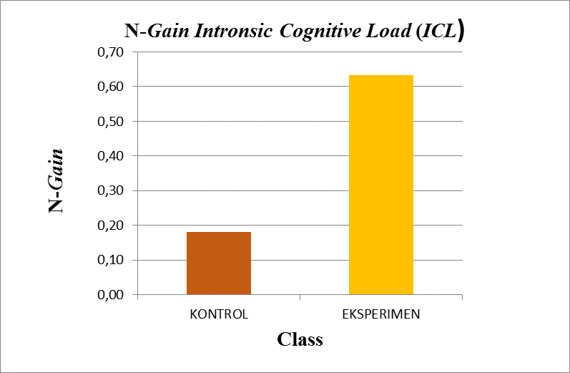

Figure 1. The Results Graph of Average Intrinsic Cognitive Load (ICL) N-gain.

The percentage of N-gain Intrinsic Cognitive Load (ICL) based on the low, moderate, and high categories using 25 students in the experimental class and 27 students in the control class. The results of the N-gain Intrinsic Cognitive Load proportion can be seen in Figure 2.

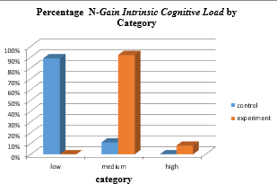
Figure 2. Persentage of ICL N-Gain Based on Category

Based on the data in Figure 2, the percentage results in the experimental class using the Inquiry Based Learning Model with an audio and visual based STEM approach experienced an increase in Intrinsic Cognitive Load in the high category by 8.00%, while in the control class using the same model and approach but not using audio and visual is 0.00%. The increase in Intrinsic Cognitive Load in the moderate category experienced an enhancement in the experimental class which was 92%, while in the control class it was 11% of students. Furthermore, the Intrinsic Cognitive Load increase in the low category in the control class experienced a high increase of 89.00%. The increase in Intrinsic Cognitive Load learning outcomes in the experimental class is because in every lesson on Newton's Law I, II, and III material, students are presented with pictures and videos of daily phenomena in real life. Newton's First Law is prsented a video of a coin placed on a ruler to prove the law of inertia. Newton's Second Law is presented a video of a broke down car being driven by one and three people to prove that mass has an effect on acceleration. Newton's third law is presented in a video of a person riding a gas bicycle, when the gas is sprayed forward the bicycle will move backwards, proving the law of action-reaction. The purpose of providing pictures and videos during learning is to motivate students to learn the Newtonian Law material. Video views to stimulate learning in Newton's First, Second and Third Laws are presented in Figures 3, 4, and 5, sequentually.

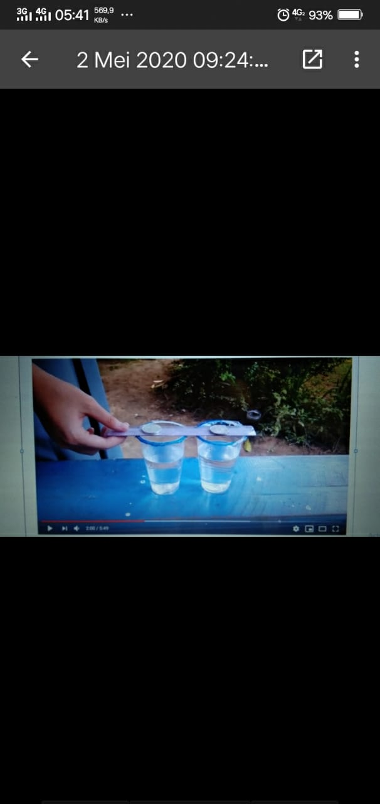
Figure 3. The Application of Newton’s 1st Law
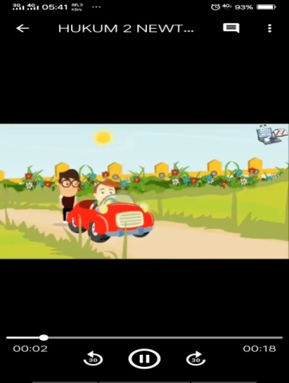
Figure 4. The Application of Newton’s 2nd Law

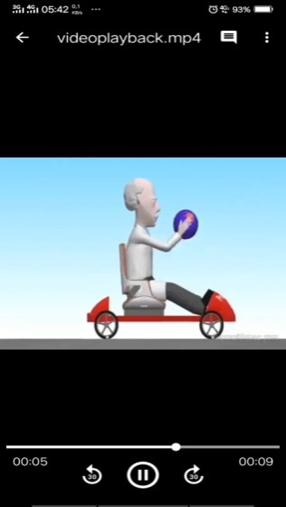
Figure 5. The Application of Newton’s 3rd Law

The lesson of Newton's Second Law is carried out practically with the help of the PHeT Simulation application. It is carried out practically using PHeT Simulation in order to attract students' attention to learn, besides that in the PHeT Simulation there is an animation of objects and humans that can be moved by students according to the instructions in the Worksheet. Students are asked to predict the acceleration relationship of an object when subjected to varying forces, to make a graph of relation between force and acceleration using Microsoft Excel. By utilizing the PHeT simulation application. Students are asked to simulate a PHeT Simulation, formulate the equation of the relationship between acceleration with mass and force, and students are asked to draw a graph of relation between force and acceleration presented on the Worksheet. The appearance of PHeT Simulation is presented in Figure 6.

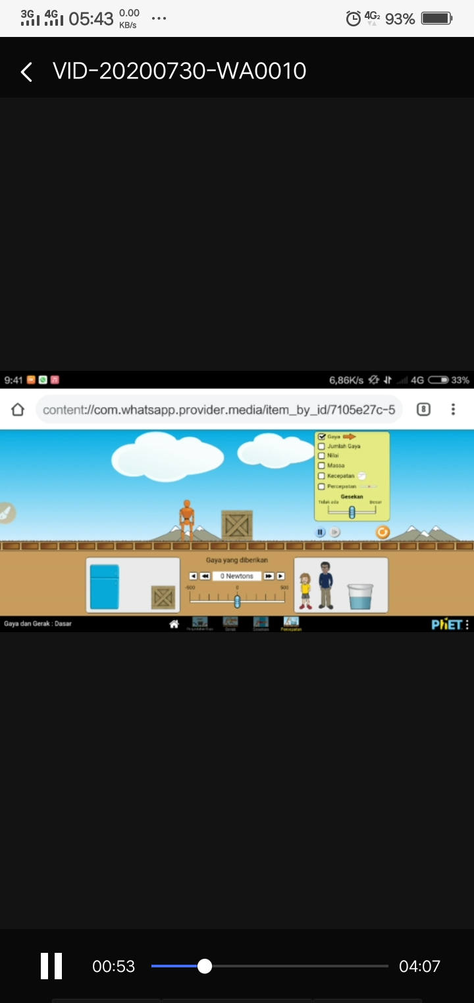
Figure 6. The Display of PHeT Simulatiom

Students have never used the PHeT Simulation application before and this is the first time, so students are curious about the PHeT Simulation application. It makes students happy in learning it and feels not overwhelmed by learning which is usually only presented with formulas. This is supported by interviews with students. The following is the transcript of the results of the researcher interview with X grade science 4 students.

G: assalamualaikum, after taught in your class, may ask about the lesson that kakak have given
S: Waalaikumussalam ms. rita. Yes kak, of course.
G: What putri think, when kakak give newton’s phenomena in daily life, is it make easier to understand the lesson?
S: Of course, when I am given the phenomena like that, putri has been easier to understand the newton’s law subject because the phenomena related to our daily life and putri think, it has never been taught kak.
G: In putri opinion, how is the lesson that presented in the form of picture and video?
S: Most of us like it kak, because it doesn’t make us feel bored. Usually the phyisics subject is only about counting, so it us feel bored and dizzy kak.
G: When practice using PHeT, do you feel dizzy or not?
S: It doesn’t make us dizzy kak, because we just first time know about that application, so it us feel coriuous, hehe.

G: Sorry, I am permission to ask about learning model using picture and video that has presented in your class. How do you think about it?
S: I think by using picture and video, the lesson is understandable compare to study system before
G: Do you feel bored?
S: I personally don’t feel bored kak,because I enjoyed it We can also understand the concept Moreover added by practice using that new application kak. Before this we have never studied like that.

G: assalamualaikum, wanna ask, how do you feel after study with mba?
S: We more understand about the concept mba, before it we feel like don’t know about the concept at all.
G: What do you think about the presentation using video and picture dek?
S: Like it so much mba, study become more enjoyable and not too much burden mba. Before it, we have never been taught about the concept. Only gift the formula, example, then doing the task mba.
Source: (The Students of Senior High School 1 Seputih Banyak, 2020)

The results of students working on the Task Complexity Worksheet which were presented in visual form after applying the Inquiry Based Learning model using the audio and visual-based STEM (Science, Tecnology, Engineering, and Mathematics) approach had increased compared to the application of the Inquiry Based Learning model using the STEM (Science, Tecnology, Engineering, and Mathematics) approach which was not based on audio and visual in learning Newton's Law of motion. This is because the STEM (Science, Tecnology, Engineering, and Mathematics) approach does not only study one scientific discipline but applies four disciplines and learning presented in audio and visual forms can facilitate student cognitive processes, so that student learning outcomes can be increased, according to the opinion of Stohlmann, et al. (2012). STEM (Science, Tecnology, Engineering, and Mathematics) approach discipline through socio-cultural learning that is relevant to the STEM content can increase interest and achievement in the fields of mathematics and science and the opinion of Mayer & Moreno (2003) that meaningful learning requires a large number of cognitive processes that take place visually and verbally.
Based on the results of hypothesis testing and the theory that has become a reference, there are differences in the increase in learning outcomes of the Task Complexity Worksheet that applies the IBL model using an audio and visual-based STEM (Science, Tecnology, Engineering, and Mathematics) approach with classes that are not audio and visual based. In the experimental class that uses audio and visual learning outcomes are higher than the control class. The increase in student learning outcomes indicates that there is a decrease in Intrinsic Cognitive Load (ICL) cognitive load. This is relevant to Muthi'ik's (2018) research which states that the average result of learning before and after learning by applying the STEM approach has increased, and research by Garnasih, Hidayat, and Rahmat (2015) states that video-based learning on Plant Diversity material can reduce students' intrinsic cognitive load.

CONCLUSION
Based on the research that has been done, there is an effect of the use of audio and visuals on decreasing the cognitive load of the experimental class. The greater the results of task complexity and a subjective rating scale, the lower the student's cognitive load.

ACKNOWLEDGMENTS
The completion of this research is certainly noe easy and there is a lot of help, coopration and guidance from various parties. Therefore, the authors would like to thanks:
- Mr Dr. Abdurrahman, M.Sc., As the Academic Advisor as well as the First Advisor for his willingness and sincerity to provide guidance, direction and motivation given during the preparation of this researh.
- Dr. Kartini Herlina, M.Sc., As Supervisor II for her willingness and sincerity to provide guidance, direction and motivation as well as very much knowledge that has been provided so far.
- Mr Dr. I Wayan District, M.Si, as the Head of the Physics Education Study Program as well as a research discussion lecturer who helped the completion of this research.
- Beloved family who always provide motivation, support, and a very sincere prayer for the success of the author
- All parties who have helped the completion of this research.

REFERENCES

Anggraeni, Ningsih. (2018). Students’ Perception Of “Full-Day School” On The Result of Learning Geography IPS Class XI of Senior High School in the State 5 District Of Luwu. LA Geografia 17(4).

Baharun, H., & Alawiyah, S. (2018). Pendidikan Full Day School dalam Perspektif EpSTEMologi Muhammad ‘Abid Al-Jabiri. Jurnal Kependidikan Islam, 4(1), 1-22.

Bransford, J.D., Brown, A.L., & Cocking, R.R. (2000). How People Learn. Brain, Mind, Experience, and, School. Washington D.C.: National Academy Press.

Collins, J. (2002). Teaching and Learning with Multimedia. Routledge. doi:10.4324/9780203441305.

Freeman, S., Eddy, S. L., McDonough, M., Smith, M. K., Okoroafor, N., Jordt, H., & Wenderoth, M. P. (2014). Active Learning Increases Student Performance In Science. Proceedings Of The National Academy Of Science Of The United States Of America, 111 (23), 8410-8415.

Ganarsih, T., Hidayat, T., Rahmat, A. (2015). Menurunkan beban kognitif intrinsic siswa MA dalam pembelajaran klasifikasi spermatophyte menggunakan tayangan video keanekaragaman tumbuhan. In seminar nasional XII pendidikan biologi UNS.

Hilalah, Nur. (2009). Tesis- Pelaksanaan Full Day School di SD Plus Nurul Hikmah Pamekasan (Telaah Problematika Perkembangan Sosial Peserta Didik). Surabaya: IAIN Sunan Ampel Surabaya.

Mayer, R. E., & Moreno, R. (2003). Nine ways to reduce cognitive load in multimedia learning. Educational Psychologist, 38, 43-52.

Muthi’ik, I.I., Abdurrahman, A., & Rosidin, U. (2018). The Effectiveness Of Applying STEM Approach To Self-Efficacy And Student Learning Outcomes For Teaching Newton’s Law. Jurnal Penelitaian & Pengembangan Pendidikan Fisika, 4(1), 11-18.

Rohman, Moh Agus. (2018). Kejenuhan Belajar pada Siswa di Sekolah SD Full Day School (Skripsi).

Savignon, Sandra J. (2007). Beyond Communicated Language Teaching. Journal of Fragmatics 39 (1): 207-220.

Stholman, M., Moore, T. J., & Roehrig, G.H. (2012). Considerations For Teaching Integrated STEM Education. Journal Of Pre-College Engineering Education Research (J-PEER), 2 (1), 4-11.

Sweller, J., Ayres, P. & Kalyuga, S. (2011) Cognitive Load Theory. New York.. Springer- Verlag: Department Education.

Sweller, J., Merrienboer, J., & Paas, F. (1998). Cognitive Architecture and Instructional Design. Educational Psychology Review, 10(3), 251-296.
Wenning, C. J.(2011). The levels of inquiry model of science teaching. Journal of Physics Teacher Education Online, 6(2), 9-16.

