**KUISIONER EVALUASI PEMBELAJARAN BIOKIMIA DI UIN SATU TULUNGAGUNG**

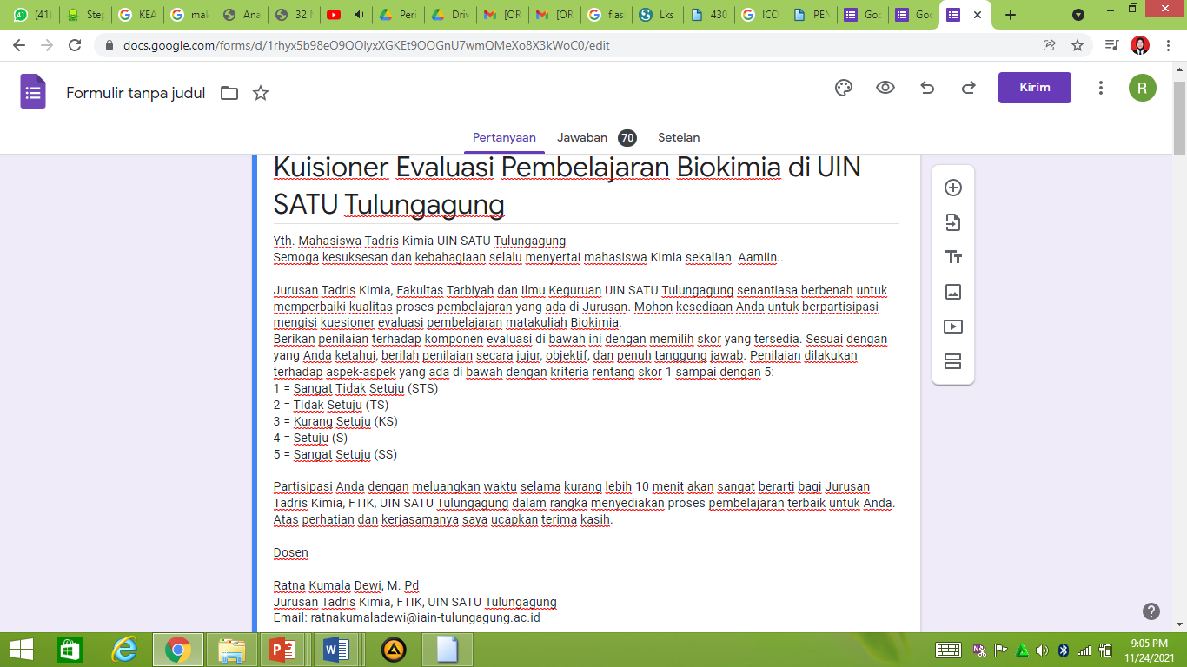

<https://docs.google.com/forms/d/1rhyx5b98eO9QOlyxXGKEt9OOGnU7wmQMeXo8X3kWoC0/edit> 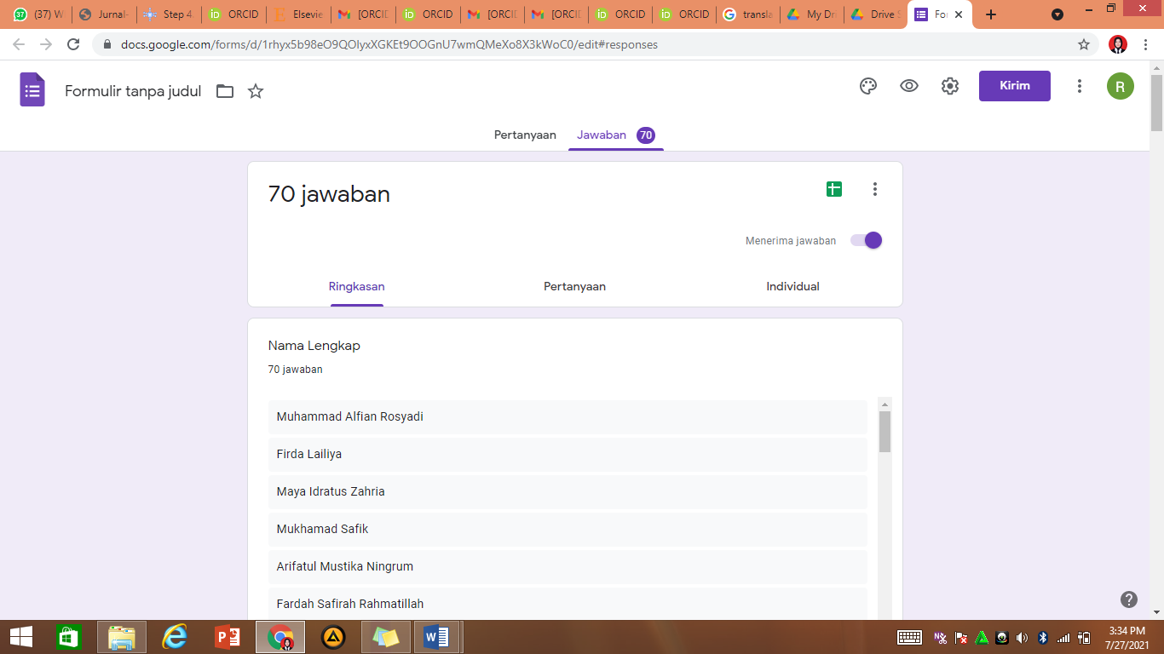

<https://docs.google.com/forms/d/1rhyx5b98eO9QOlyxXGKEt9OOGnU7wmQMeXo8X3kWoC0/edit#responses>

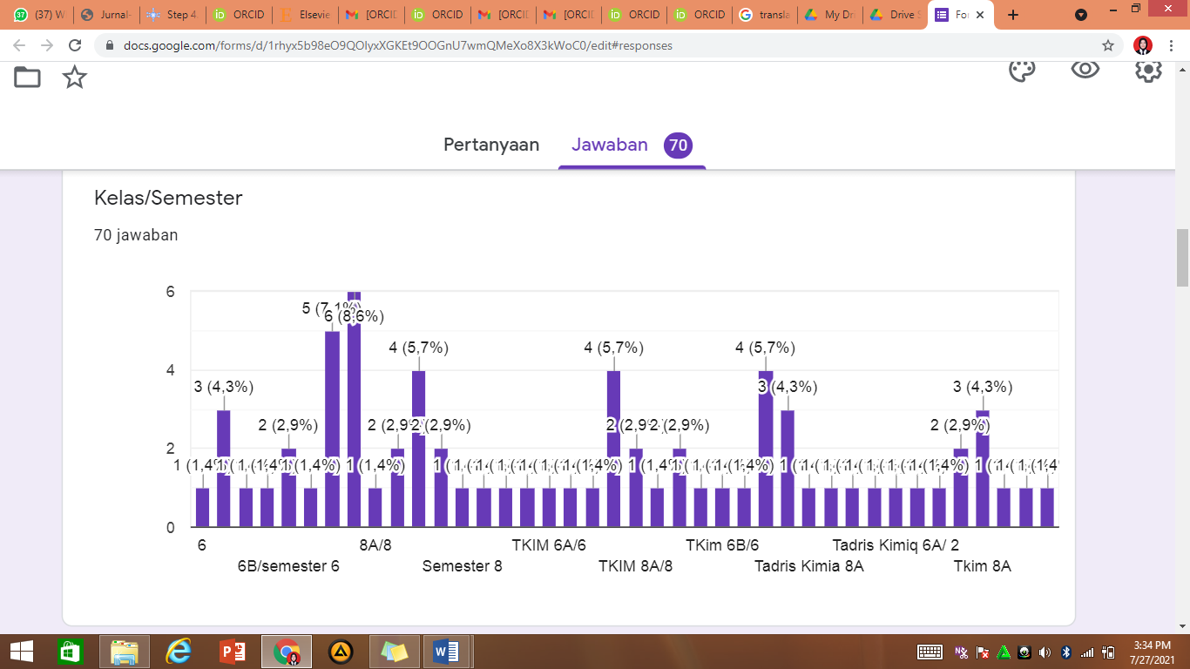

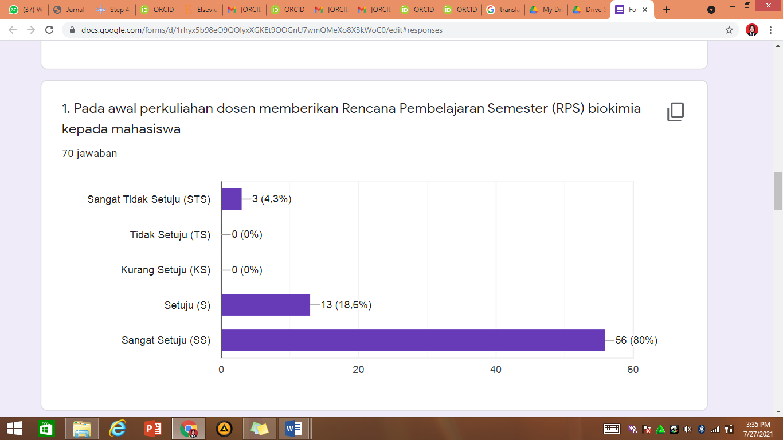

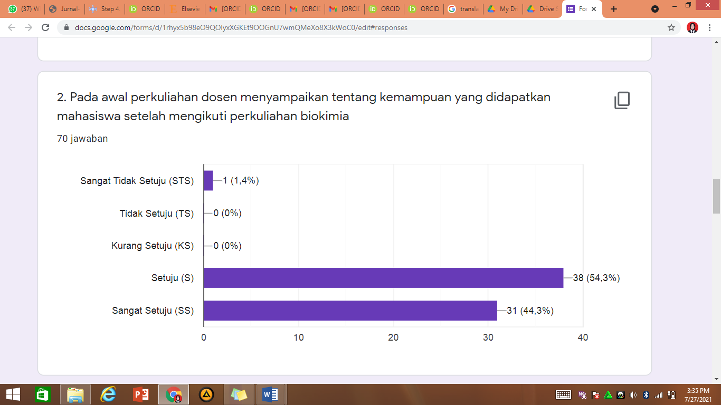

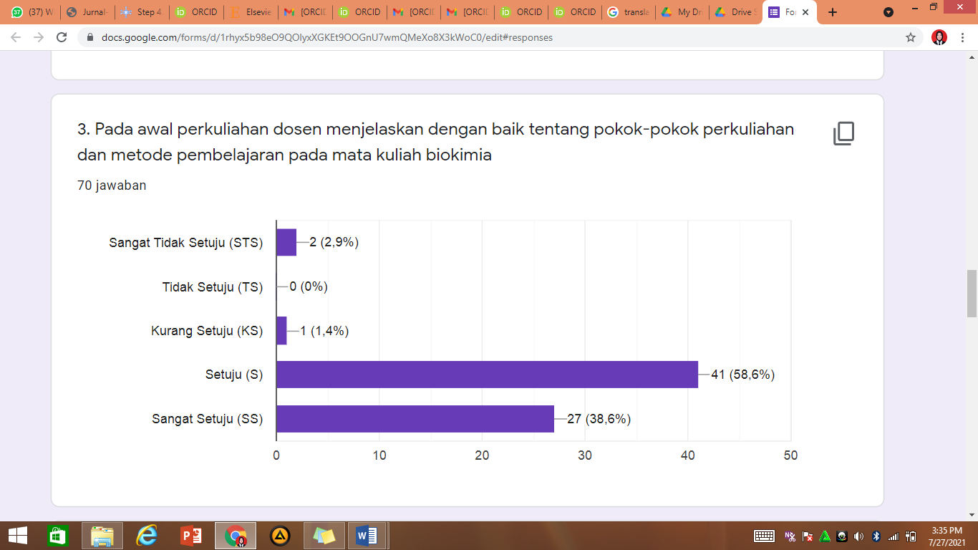

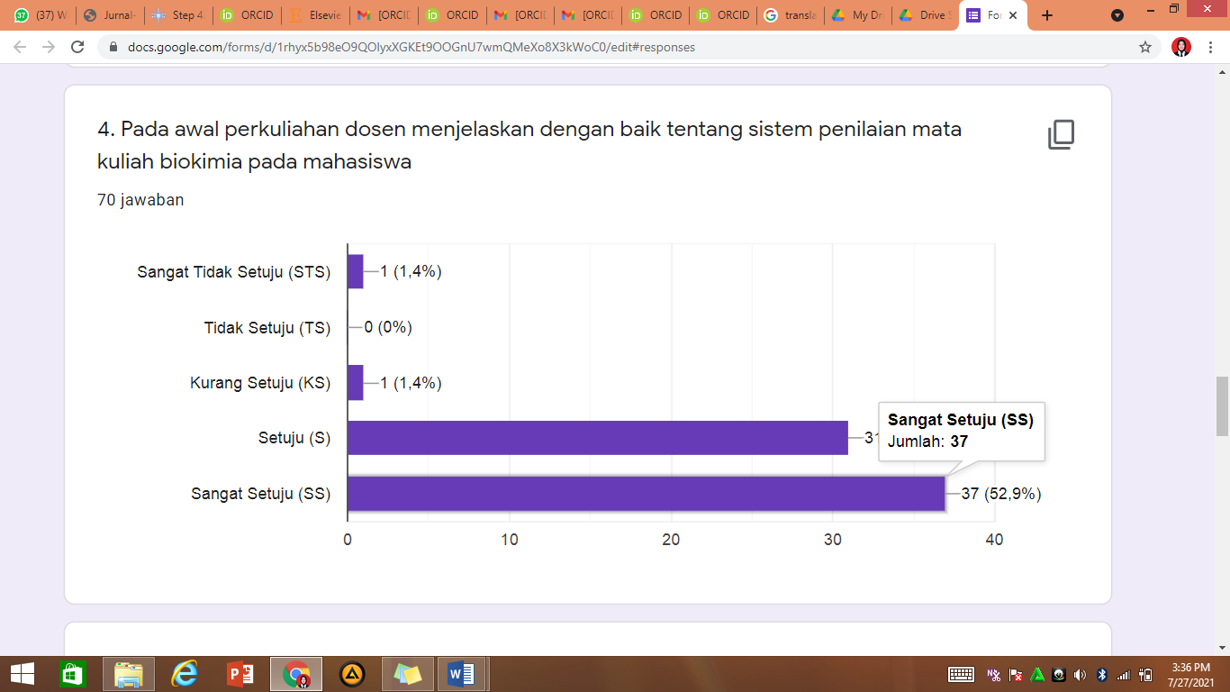

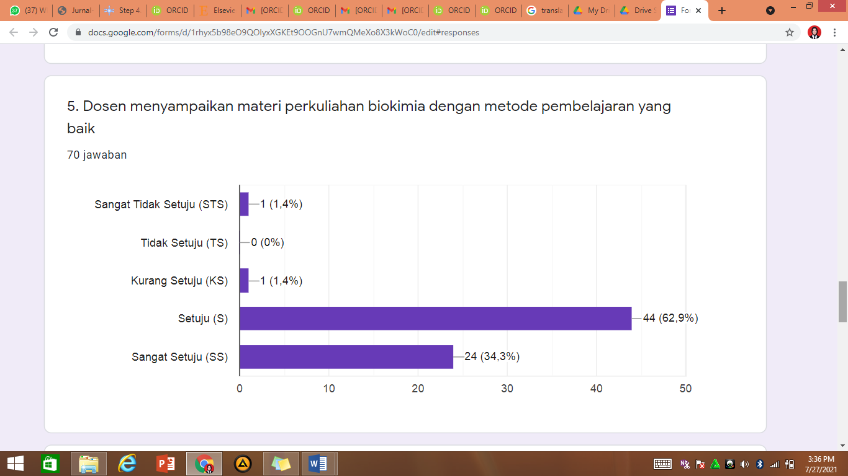

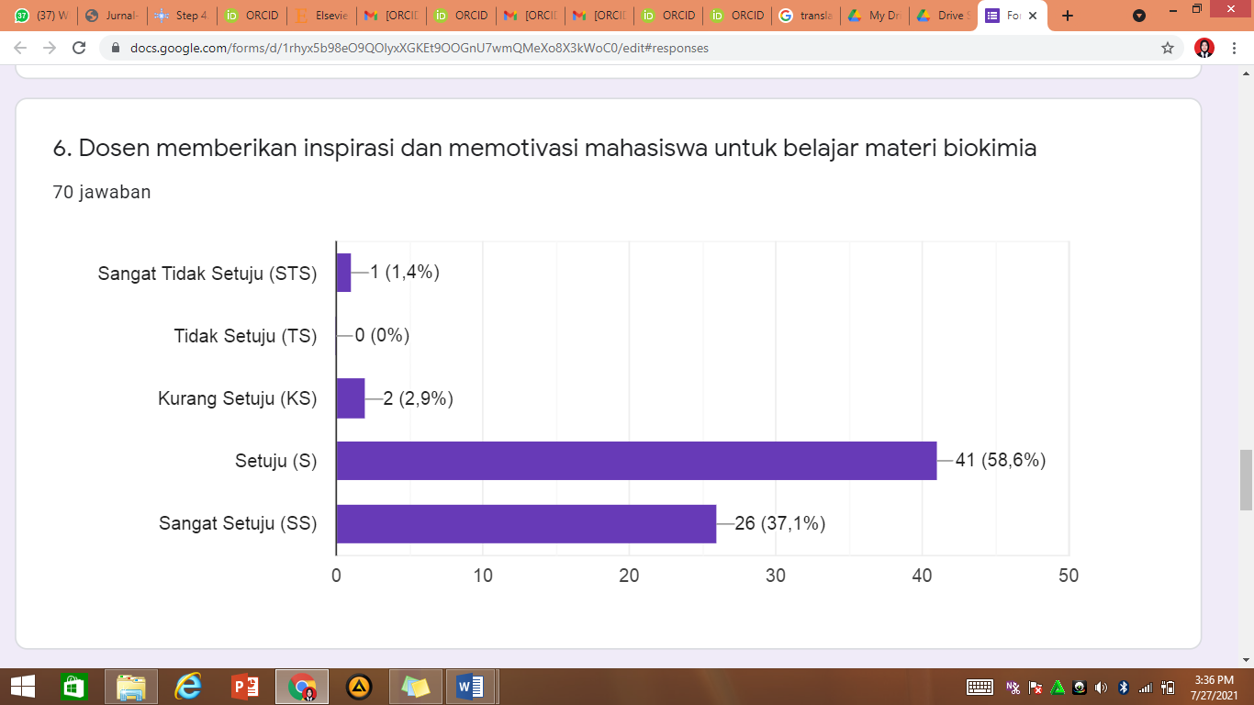

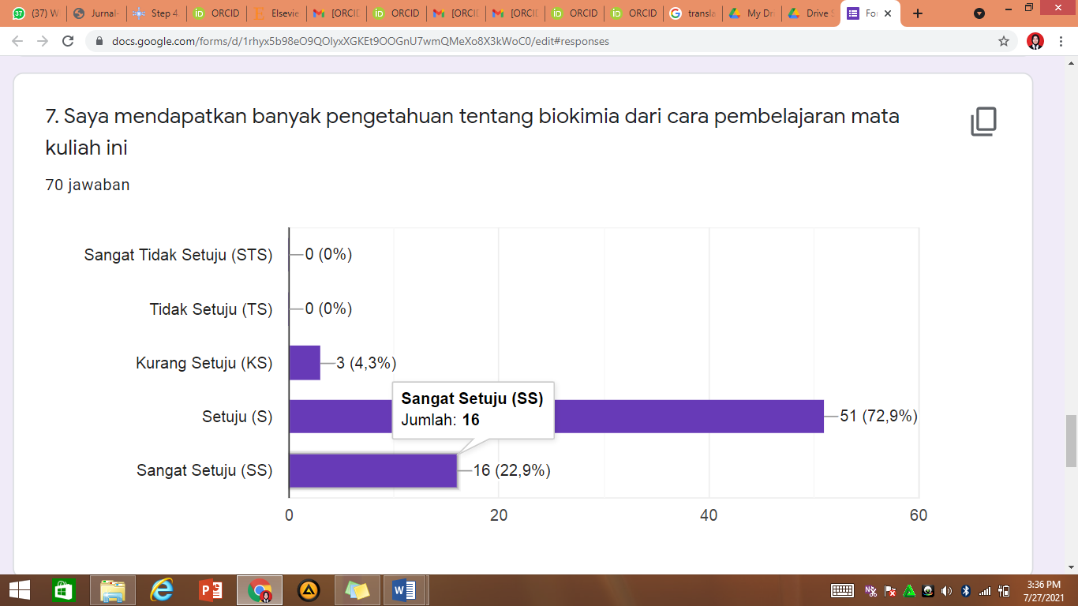

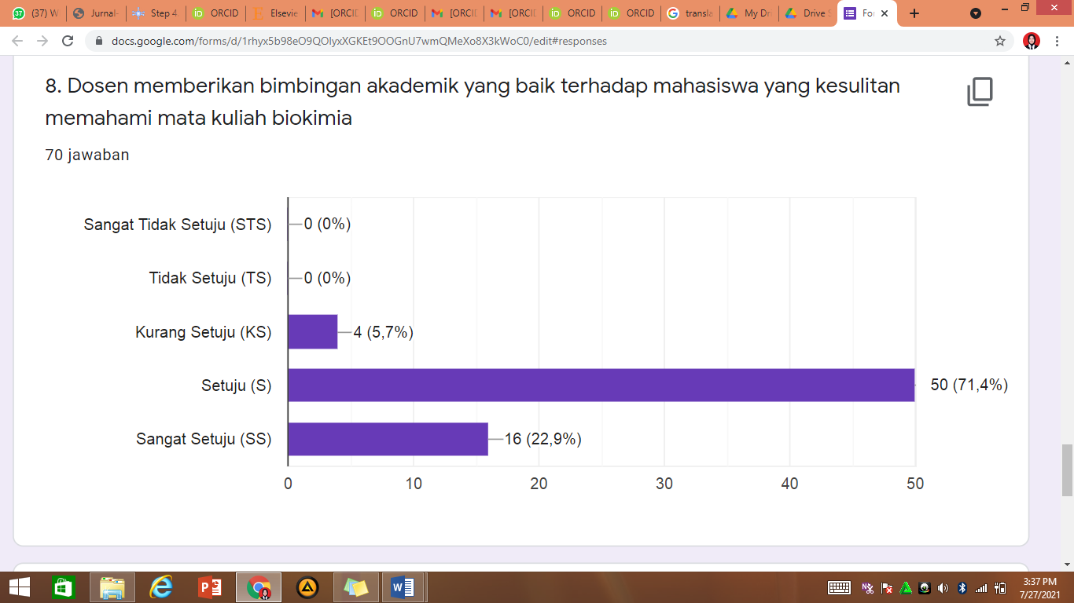

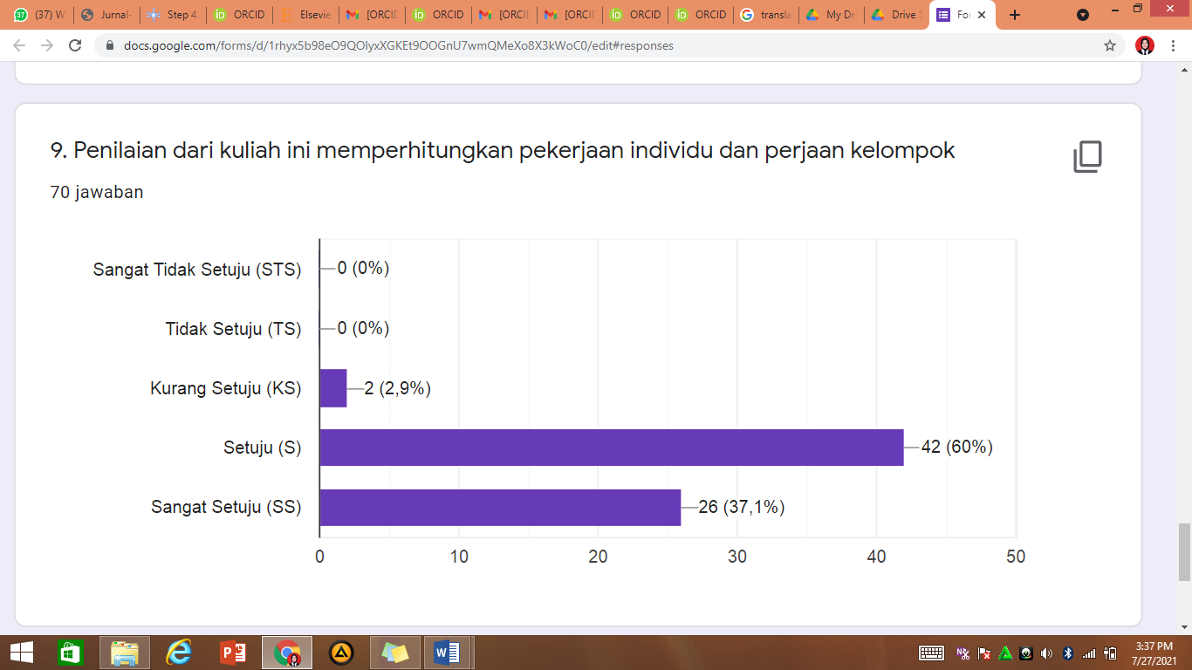

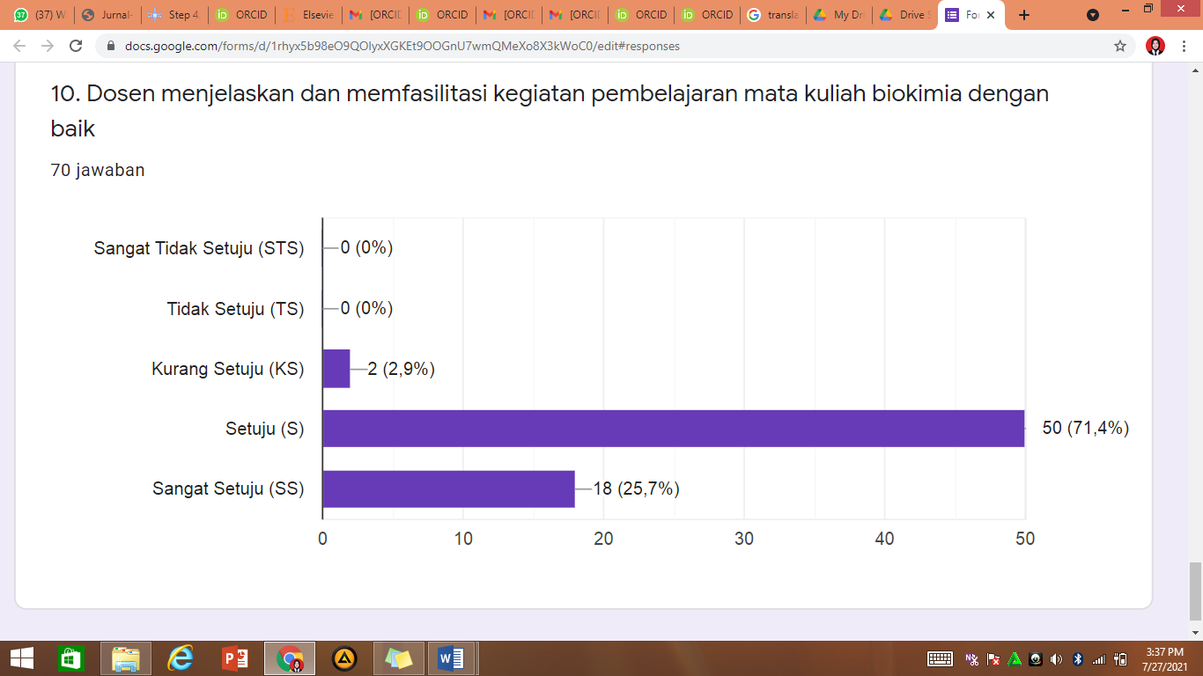

**KUISIONER EVALUASI KETERAMPILAN (SKILLS) PEMBELAJARAN BIOKIMIA DI UIN SATU TULUNGAGUNG**

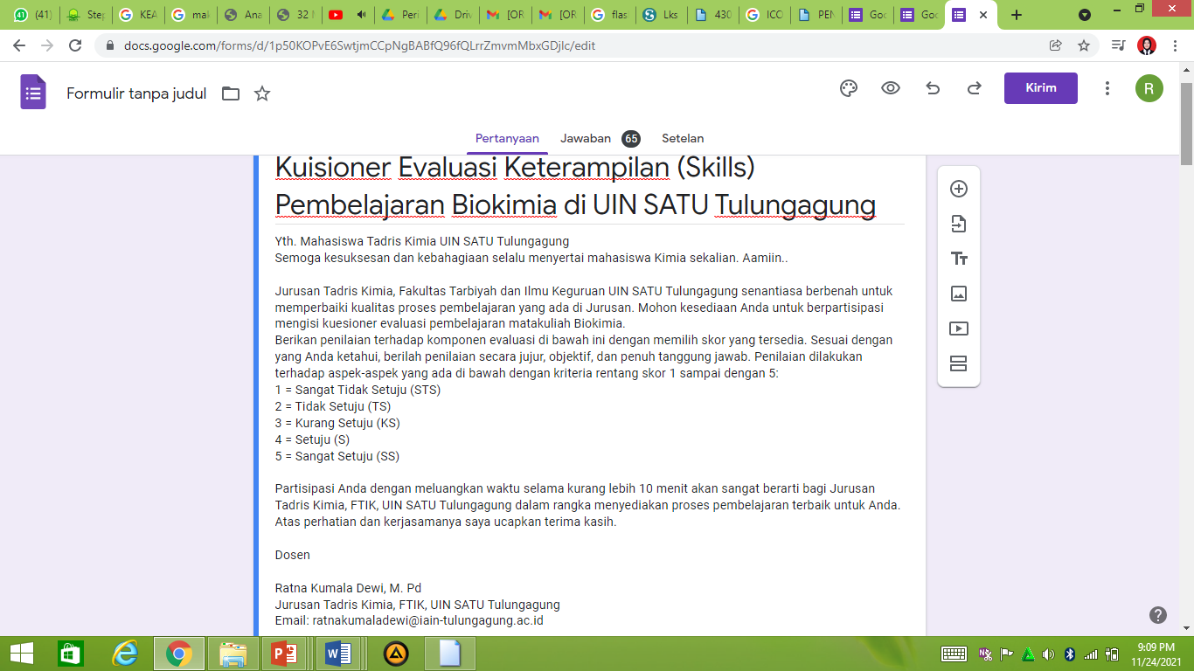

<https://docs.google.com/forms/d/1p50KOPvE6SwtjmCCpNgBABfQ96fQLrrZmvmMbxGDjlc/edit>

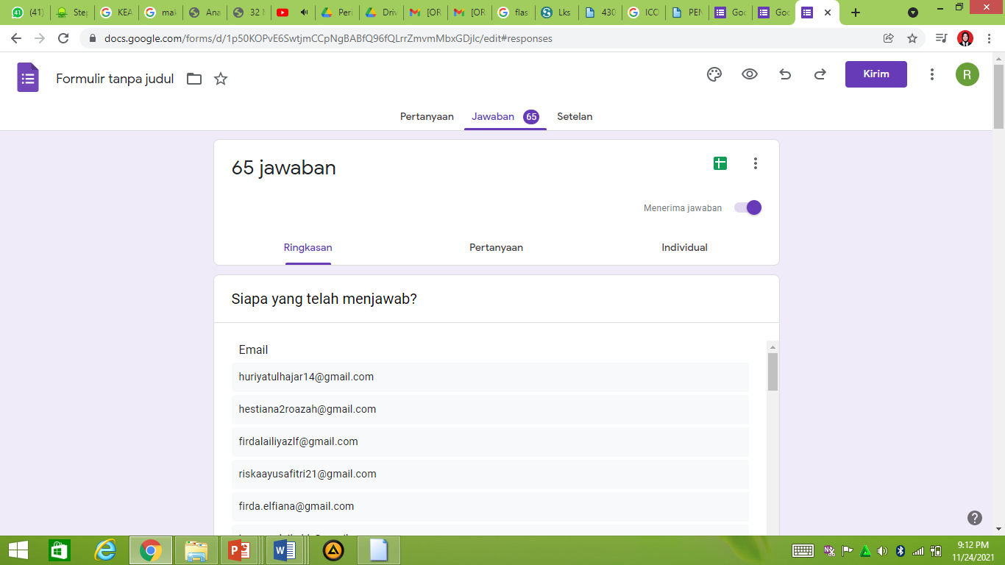

<https://docs.google.com/forms/d/1p50KOPvE6SwtjmCCpNgBABfQ96fQLrrZmvmMbxGDjlc/edit#responses>

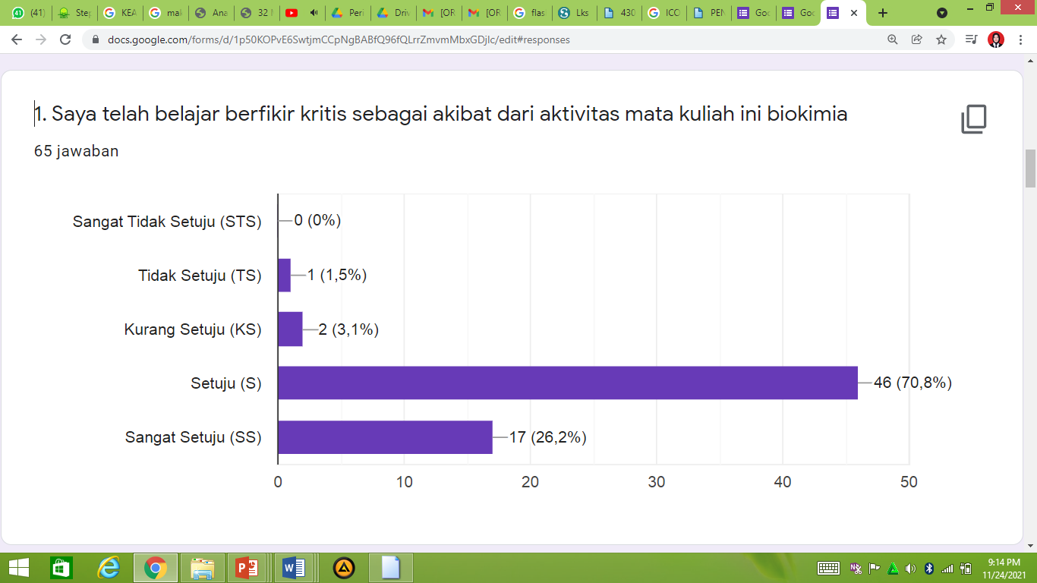

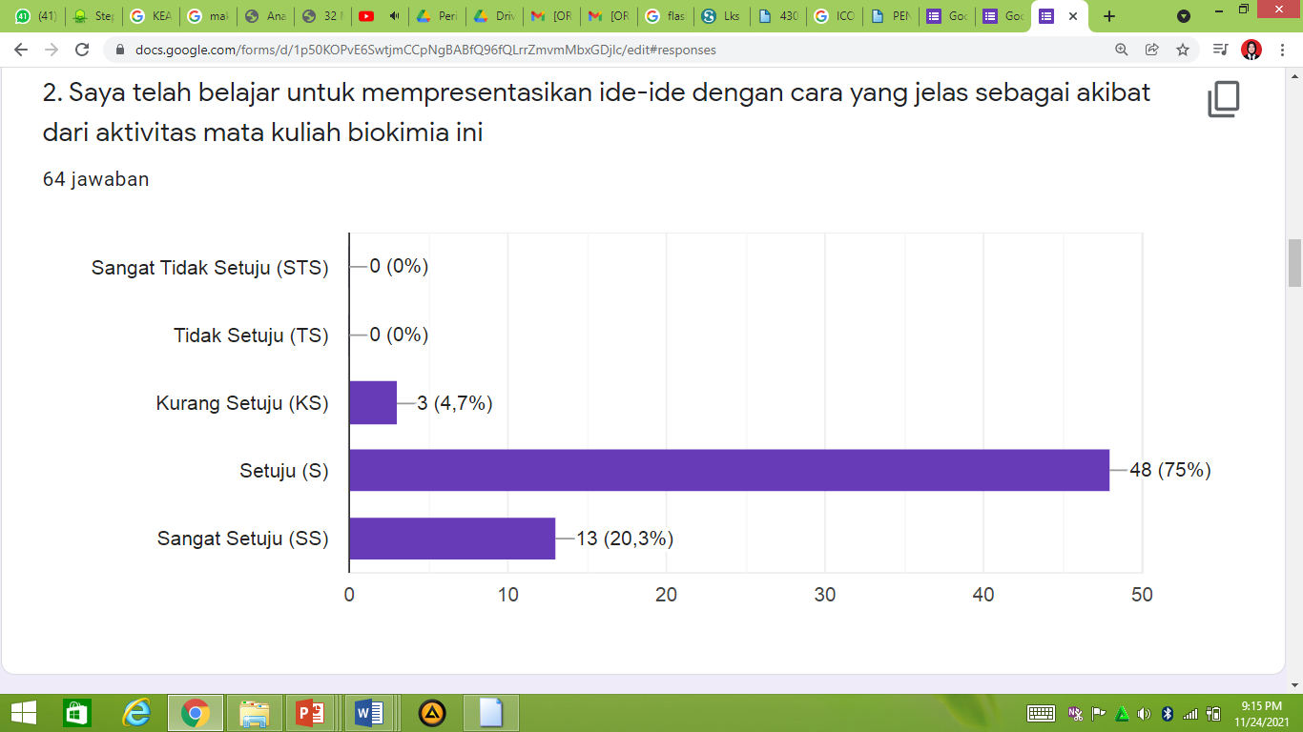

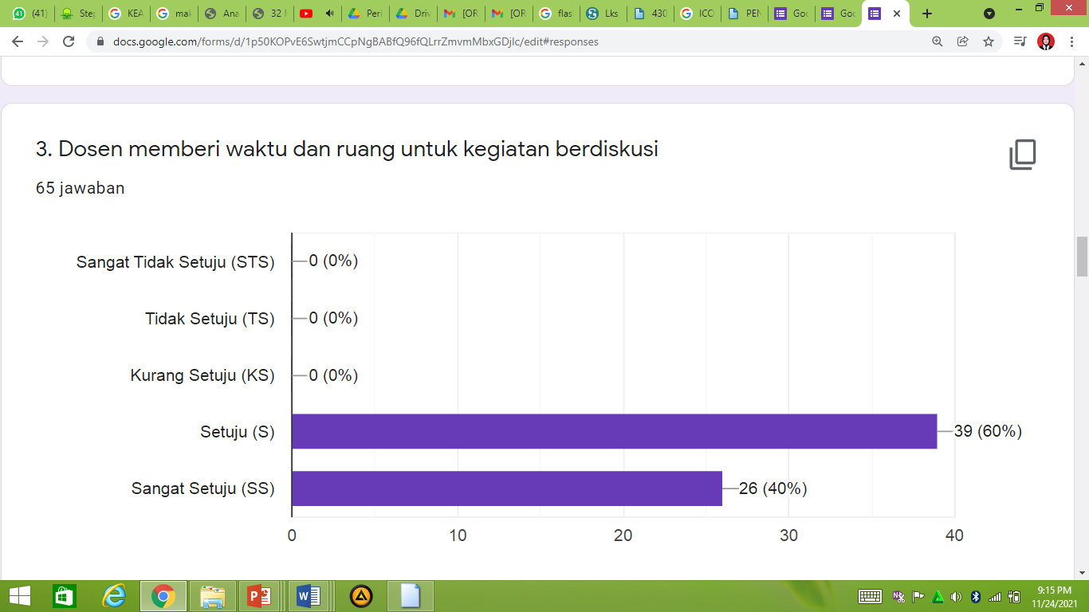

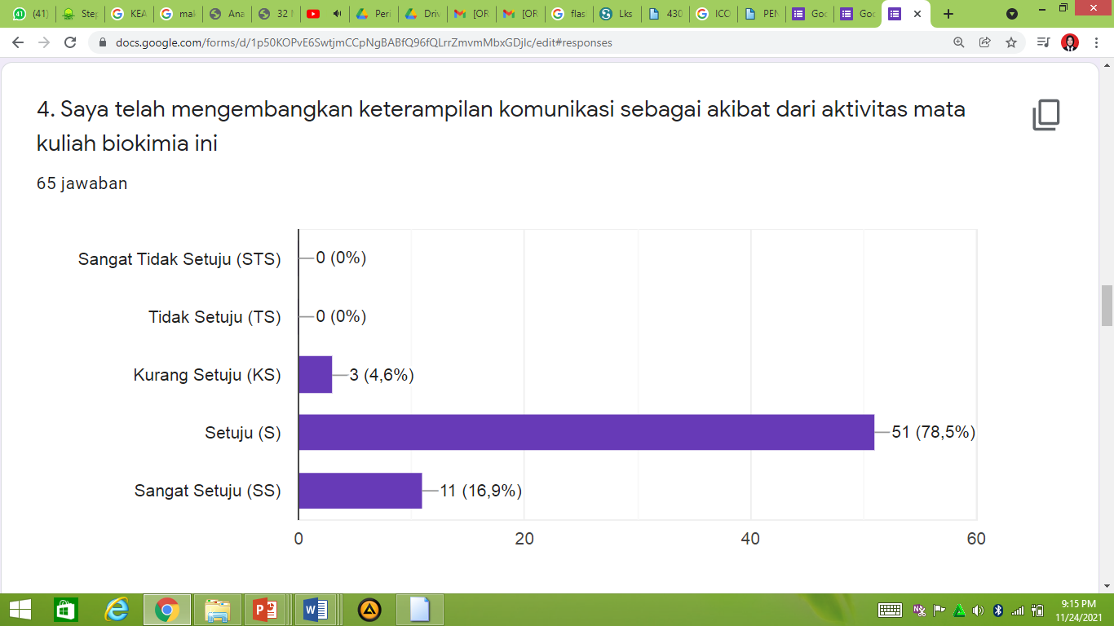

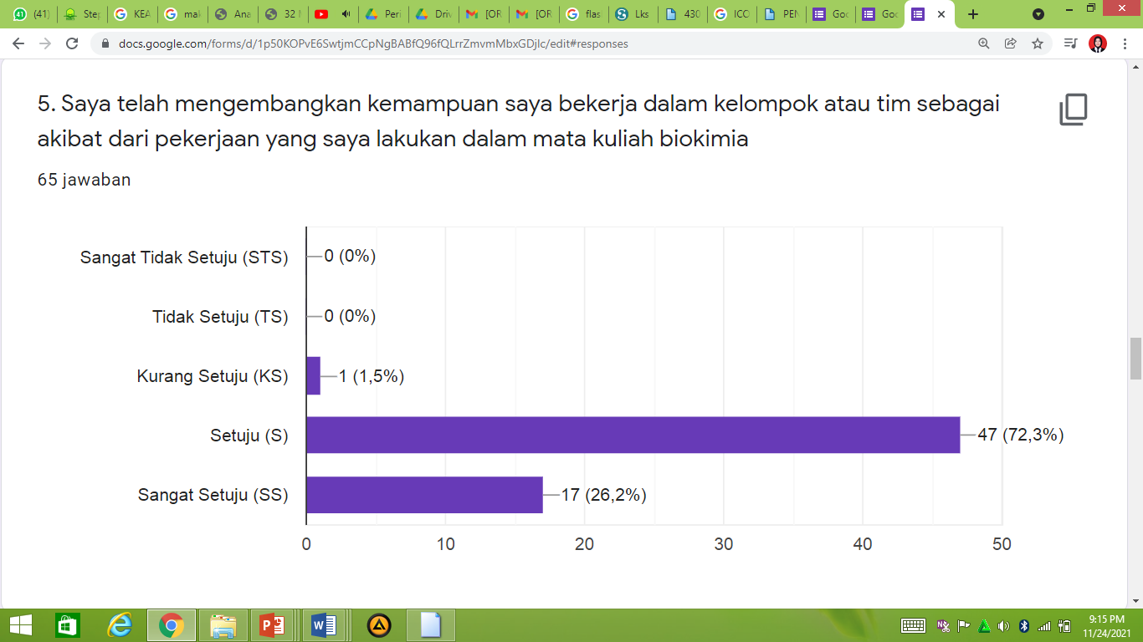

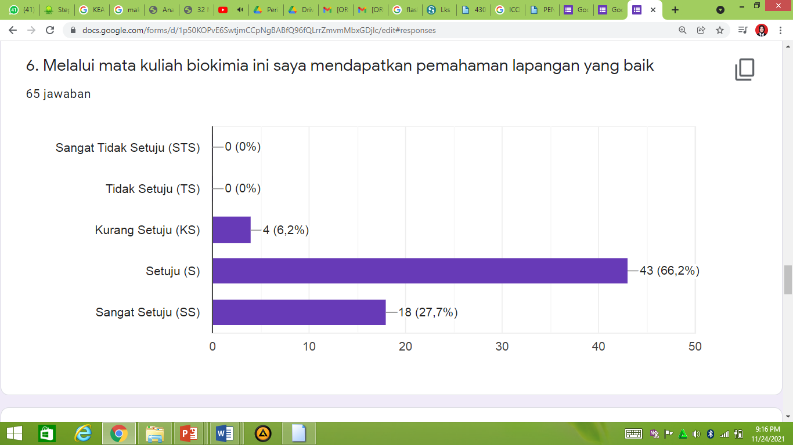

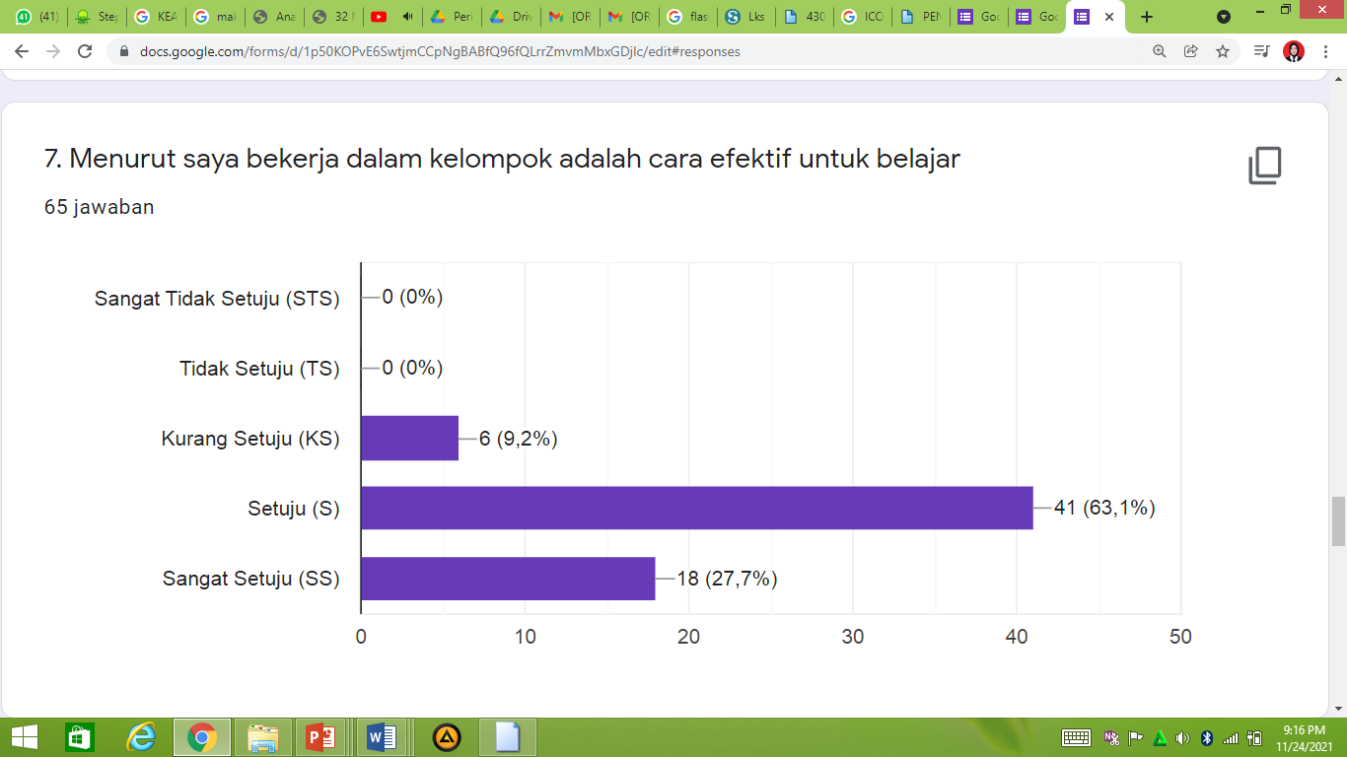

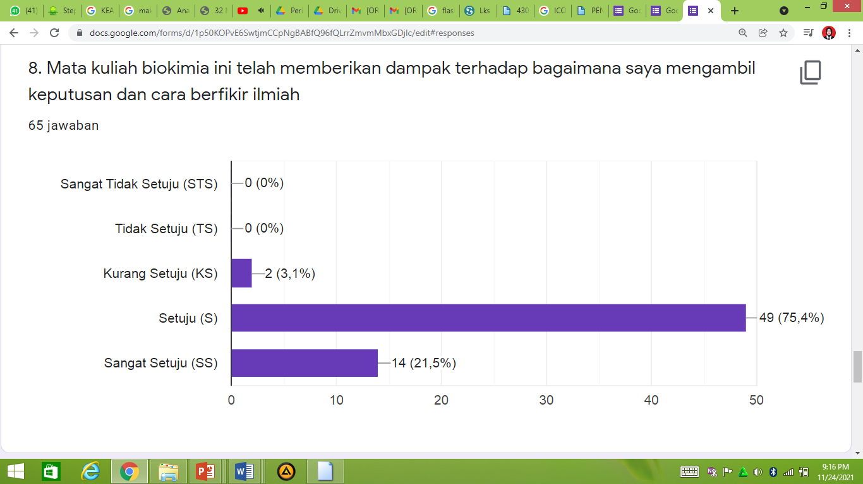

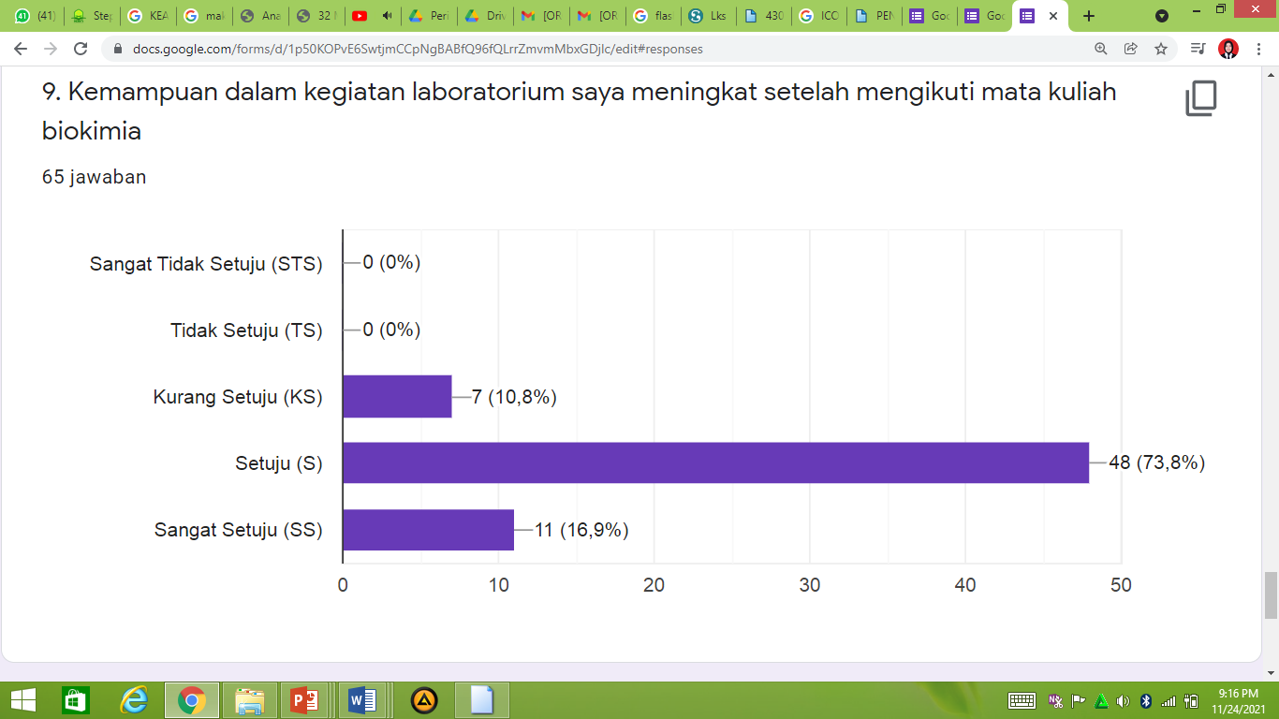

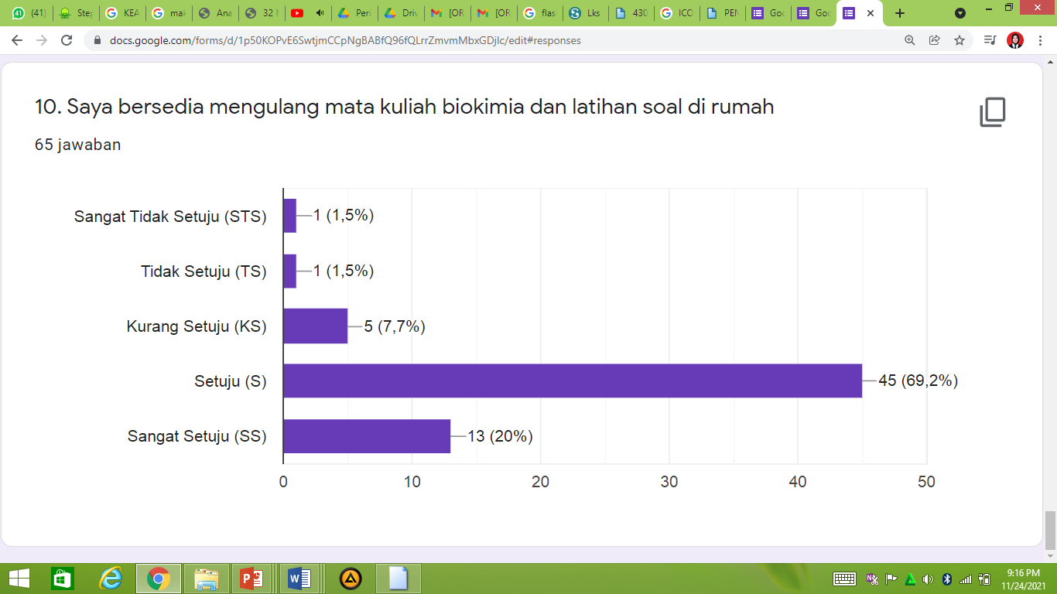

**KUISIONER EVALUASI SARANA PRASARANA PEMBELAJARAN BIOKIMIA DI UIN SATU TULUNGAGUNG**

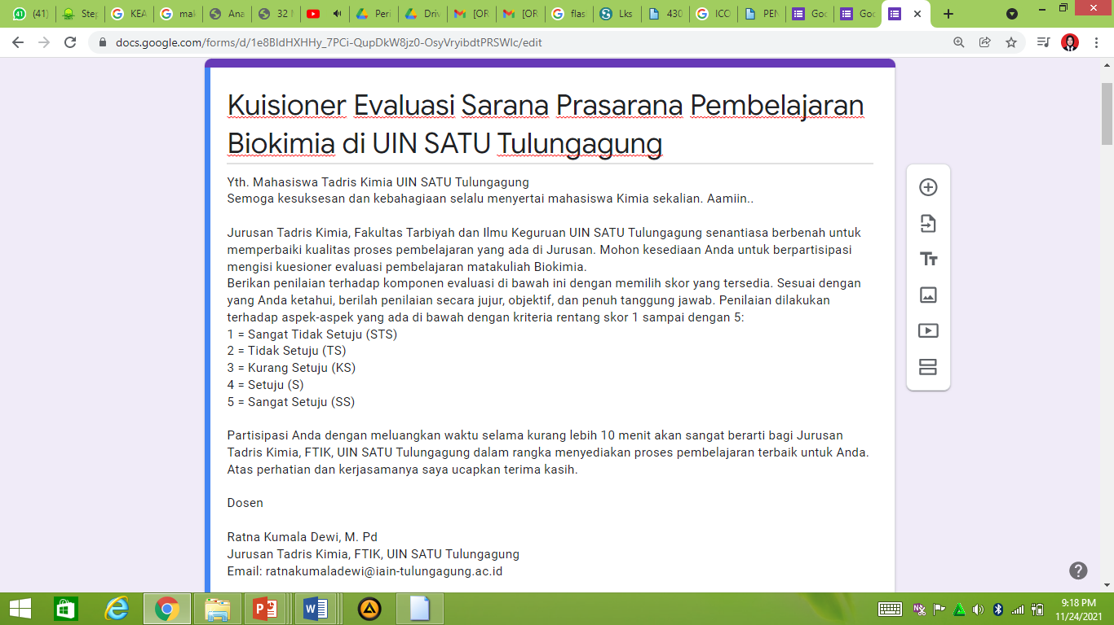

[**https://docs.google.com/forms/d/1e8BIdHXHHy_7PCi-QupDkW8jz0-OsyVryibdtPRSWlc/edit**](https://docs.google.com/forms/d/1e8BIdHXHHy_7PCi-QupDkW8jz0-OsyVryibdtPRSWlc/edit)

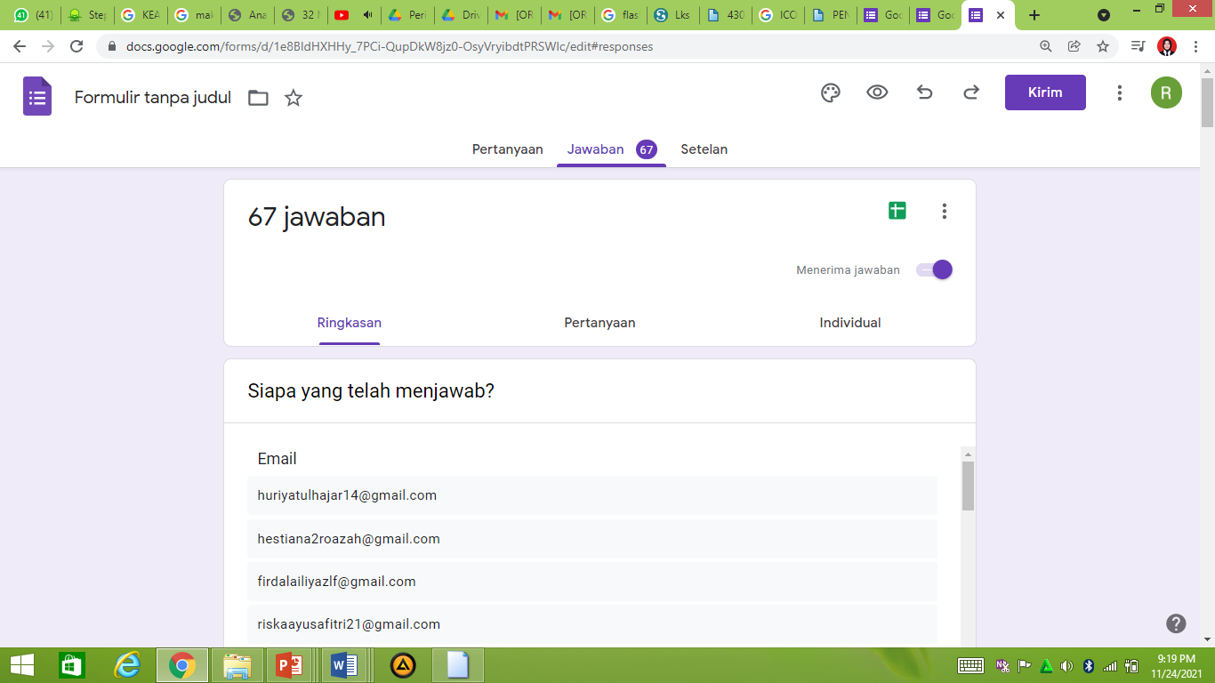

[**https://docs.google.com/forms/d/1e8BIdHXHHy_7PCi-QupDkW8jz0-OsyVryibdtPRSWlc/edit#responses**](https://docs.google.com/forms/d/1e8BIdHXHHy_7PCi-QupDkW8jz0-OsyVryibdtPRSWlc/edit#responses)

